# CHAPTER 1 - PROBLEM DEFINITION/INTRODUCTION

## 1.1 Existing System Study & Its Limitations

Fire detection systems are essential for ensuring safety in various environments, including residential homes, commercial buildings, and industrial facilities. These systems are designed to detect the presence of fire or smoke and alert occupants to potential dangers. However, traditional fire detection systems, which primarily rely on physical sensors, have several limitations that can compromise their effectiveness and reliability.

### 1.1.1 Types of Existing Fire Detection Systems

1. **Smoke Detectors:**
   * Ionization Detectors: These detectors are sensitive to fast-flaming fires. They contain a small amount of radioactive material that ionizes the air in the sensing chamber. When smoke enters the chamber, it disrupts the ionization process, triggering the alarm. However, they are prone to false alarms from cooking fumes or steam.
   * Photoelectric Detectors: These detectors use a light beam to detect smoke. When smoke enters the chamber, it scatters the light beam, triggering the alarm. They are more effective at detecting smoldering fires but can also be triggered by nonfire-related smoke.
2. **Heat Detectors:**
   * These devices respond to changes in temperature. They can be fixedtemperature detectors, which activate when a specific temperature is reached, or rate-of-rise detectors, which trigger an alarm when the temperature increases rapidly. While they are less prone to false alarms, they may not detect a fire until it has generated significant heat.
3. **Flame Detectors:**
   * These systems detect the infrared or ultraviolet radiation emitted by flames. They are typically used in high-risk environments, such as industrial settings, where rapid detection is critical. However, they require a clear line of sight to the fire and can be expensive to install and maintain.
4. **Manual Call Points:**
   * These devices allow individuals to manually trigger an alarm in case of a fire. They rely on human intervention, which can lead to delays in alerting others, especially in large or complex buildings.

### 1.1.2 Limitations of Existing Systems

**Despite their widespread use, traditional fire detection systems have several limitations:**

False Alarms: One of the most significant issues with sensor-based fire detection systems is the prevalence of false alarms. Environmental factors such as dust, steam, cooking fumes, and even insects can trigger alarms, leading to unnecessary evacuations

and loss of trust in the system. Studies indicate that false alarms can account for up to 90% of all fire alarms in some settings, causing alarm fatigue among occupants.

Installation Costs: The installation of physical fire detection systems can be prohibitively expensive, particularly in large buildings or remote areas. Costs associated with hardware, labor, and compliance with local regulations can deter organizations from implementing comprehensive fire safety measures. For instance, retrofitting an existing building with a new fire detection system can involve significant expenses.

* Maintenance Requirements: Regular maintenance is essential to ensure that fire detection systems function correctly. This maintenance can be labor-intensive and costly, involving routine inspections, battery replacements, and repairs. Neglecting maintenance can lead to system failures during critical moments, putting lives and property at risk.
* Limited Coverage: Physical sensors have a limited range and may not cover all areas effectively. This limitation can lead to blind spots in fire detection, particularly in complex building layouts where obstacles may obstruct sensor detection. For example, a smoke detector placed in a corner may not detect smoke from a fire occurring in the center of a room.
* Response Time: Traditional systems may not provide real-time alerts to the appropriate personnel, leading to delays in response times. In emergencies, every second counts, and delayed notifications can exacerbate the situation. The time taken for alarms to be triggered and for occupants to respond can significantly impact the outcome of a fire incident.
* Inflexibility: Once installed, physical fire detection systems are often difficult to modify or expand. Changes in building layout or usage may require significant reconfiguration of the fire detection system. This inflexibility can hinder organizations from adapting to new safety requirements or changes in occupancy.

## 1.2 Proposed System Justify Its Need

The proposed system, "Fireguardian" aims to address the limitations of traditional fire detection systems by utilizing a software-based approach that leverages machine learning and data analytics. The need for this system arises from several key factors:

### 1.2.1 Cost-Effectiveness (Continued)

This cost-effectiveness makes fire detection systems more accessible to a broader range of users, including small businesses, residential properties, and even large industrial facilities. The financial benefits can be broken down as follows: No Hardware Costs: By relying on software and existing data sources, organizations can avoid the significant upfront costs associated with purchasing and installing multiple physical sensors.

* Reduced Labor Costs: The need for professional installation and ongoing maintenance is minimized, allowing organizations to allocate resources more effectively.
* This particularly beneficial for smaller organizations that may not have the budget for extensive safety infrastructure.
* Lower Compliance Costs: With fewer physical components, compliance with fire safety regulations may become less complex and costly. Organizations can focus on software updates and data management rather than hardware inspections and replacements.

### 1.2.2 Scalability

The software-based nature of Fireguardian allows for easy scalability. Key aspects of scalability include:

* Flexible Deployment: The system can be deployed in various environments, from small homes to large industrial complexes, without the constraints of physical sensor placement. This flexibility allows organizations to implement fire detection solutions that fit their specific needs.
* Adaptable Architecture: As an organization grows or changes, the system can be easily updated or expanded to accommodate new requirements. For example, if a business expands its operations to a new location, the existing software can be configured to monitor the new site without the need for additional hardware.
* Remote Monitoring: Users can monitor multiple locations from a single interface, making it easier to manage fire safety across different sites. This is particularly advantageous for organizations with multiple facilities or remote operations.

### 1.2.3 Real-Time Monitoring and Alerts

Fireguardian provides real-time monitoring and alerting capabilities through a user-friendly web interface. This feature enhances fire safety in several ways:

* Immediate Notifications: Users receive instant alerts when the system identifies potential fire risks, allowing for quicker response times. This immediacy can be crucial in preventing small incidents from escalating into major disasters.
* Continuous Monitoring: The system continuously analyzes data inputs to detect anomalies, ensuring that users are always informed of their environment's safety status. This proactive approach allows organizations to address potential issues before they become critical.

User -Friendly Dashboard: The web interface provides an intuitive dashboard for users to monitor real-time data and alerts easily. Users can customize their views to focus on the most relevant information for their specific needs.

### 1.2.4 Integration with Existing Systems

**Fireguardian is designed to integrate seamlessly with existing building management systems** (BMS) and other safety protocols. This integration offers several advantages:

* Holistic Safety Management: By combining fire detection with other safety measures (e.g., security systems, HVAC controls), organizations can create a comprehensive safety strategy that addresses multiple risks. For instance, if a fire is detected, the system can automatically trigger alarms, lock doors, or adjust ventilation systems to contain the fire.

Data Sharing: Integration allows for the sharing of data between systems, enhancing the overall effectiveness of safety measures. For example, if a fire is detected, the system can communicate with the building's security system to initiate an evacuation protocol.

* Streamlined Operations: A unified system reduces the complexity of managing multiple safety protocols, making it easier for staff to respond to emergencies and maintain compliance with safety regulations. This streamlining can lead to more efficient operations and better resource allocation.
* Enhanced Reporting: Integrated systems can generate comprehensive reports that provide insights into safety performance, helping organizations identify areas for improvement. These reports can be invaluable for audits, compliance checks, and safety training.

### 1.2.5 Enhanced Data Analytics

Fireguardian leverages advanced data analytics to improve fire detection capabilities. By analyzing historical data, environmental conditions, and user inputs, the system can:

* Identify Patterns: Machine learning algorithms can identify patterns and trends in data that may indicate potential fire hazards. For example, the system can analyze temperature fluctuations, humidity levels, and occupancy data to predict when and where fires are most likely to occur.
* Predictive Analytics: The system can use predictive analytics to forecast potential fire risks based on current and historical data. This proactive approach allows organizations to take preventive measures before a fire occurs, enhancing overall safety.
* Continuous Improvement: As the system collects more data over time, it can continuously improve its algorithms and predictions. This adaptability ensures that the system remains effective in changing environments and conditions.

## 1.3 Summary of the Proposed System

The Fireguardian system represents a significant advancement in fire detection technology by addressing the limitations of traditional sensor-based systems. By leveraging software solutions, machine learning, and real-time monitoring, Fireguardian offers a cost-effective, scalable, and efficient alternative for fire safety management.

### 1.3.1 Key Features of Fireguardian

* Machine Learning Algorithms: The system employs machine learning to analyze environmental data and predict potential fire hazards, improving accuracy and reducing false alarms. By training on historical data, the algorithms can learn to differentiate between normal environmental variations and indicators of fire risk.
* Web-Based Interface: Users can access the system from any device with internet connectivity, allowing for remote monitoring and management. This flexibility ensures that users can stay informed about fire risks regardless of their location.
* Customizable Alerts: Users can set preferences for alerts based on their specific needs and risk profiles. This customization allows organizations to tailor the system to their unique environments, ensuring that they receive relevant notifications without being overwhelmed by unnecessary alerts.
* Data Analytics: The system provides insights into fire risk trends, enabling organizations to make informed decisions about fire safety measures. Users can analyze historical data to identify patterns and assess the effectiveness of their fire prevention strategies.
* Integration Capabilities: Fireguardian can be integrated with existing building management systems, enhancing overall safety and operational efficiency. This integration allows for a more comprehensive approach to safety management, combining fire detection with other critical systems.
* User Training and Support: The system will include resources for user training and support, ensuring that users can effectively utilize the platform. This may include tutorials, documentation, and access to customer support for troubleshooting and assistance.

## 1.4 Future Directions

The Fireguardian system is not just a solution for today; it is designed with future advancements in mind. As technology evolves, the system can incorporate new features and capabilities, such as:

* Artificial Intelligence (AI): Future iterations may integrate AI to enhance decisionmaking processes, allowing the system to learn from user interactions and environmental changes more effectively. AI could also facilitate more sophisticated predictive analytics, improving the system's ability to anticipate fire risks.

* Mobile Application: Developing a mobile application could provide users with even greater accessibility and convenience. A mobile app could allow users to receive alerts, monitor conditions, and access data on the go, further enhancing their ability to respond to potential fire hazards.
* Community Engagement: Incorporating community features could allow users to share information and experiences related to fire safety. This could include forums for discussing best practices, sharing incident reports, and collaborating on safety initiatives.
* Global Data Integration: The system could potentially integrate with global databases of fire incidents and environmental conditions, providing users with a broader context for understanding fire risks. This integration could enhance the system's predictive capabilities by incorporating data from various geographical locations.

# CHAPTER 2 - OBJECTIVE AND SCOPE OF THE PROJECT

## 2.1 About the System

Fireguardian is an innovative fire detection system designed to enhance safety protocols in various environments, including residential, commercial, and industrial settings. Unlike traditional fire detection systems that rely on physical sensors, Fireguardian leverages advanced machine learning algorithms to analyze data from multiple sources, providing a more reliable and efficient means of detecting potential fire hazards.

### 2.1.1 System Architecture

The architecture of Fireguardian consists of several key components:

* **Data Collection Module**: This module gathers data from various sources, including:
* **Environmental Sensors**: While the system does not rely solely on physical sensors, it can integrate with existing environmental sensors (e.g., temperature and humidity sensors) to enhance data accuracy.
* **Historical Fire Data**: The system analyzes historical fire incident reports to identify patterns and trends that may indicate potential fire risks.
* **External Data Sources**: Fireguardian can pull data from external sources to assess environmental conditions that may contribute to fire hazards.
* **Data Processing Module**: This module processes the collected data using machine learning algorithms.
* **Data Cleaning**: Raw data is cleaned and preprocessed to remove noise and irrelevant information.
* **Feature Extraction**: Relevant features are extracted from the data to improve the accuracy of the machine learning models.
* **Model Training**: Machine learning models are trained using historical data to recognize patterns associated with fire incidents.
* **Alert Generation Module**: Once potential fire hazards are identified, the system generates alerts. This module includes:
* **Real-Time Monitoring**: Continuous monitoring of environmental conditions and data inputs to detect anomalies.
* **Alert Mechanism**: The system sends real-time alerts to users via email, SMS, or push notifications, ensuring timely responses to potential fire threats.
* **User Interface**: The web-based interface allows users to:
* **Monitor Data**: Users can view real-time data visualizations, including temperature and humidity levels, as well as historical trends.
* **Receive Alerts**: Users can access alerts and notifications regarding potential fire hazards.
* **Customize Settings**: Users can customize alert thresholds and notification preferences based on their specific needs.

### 2.1.2 Technology Stack

Fireguardian is built using a robust technology stack that includes:

* **Python**: The primary programming language used for developing the backend of the application. Python's extensive libraries for data analysis and machine learning make it an ideal choice for this project.
* **Flask**: A lightweight web framework for Python that allows for the rapid development of web applications. Flask provides the necessary tools to create a user-friendly interface for monitoring and alerting.
* **Machine Learning Libraries**: Libraries such as Scikit-learn, TensorFlow, or PyTorch are utilized for implementing machine learning algorithms that analyze data and predict fire hazards.
* **Database**: A database (e.g., SQLite, PostgreSQL) is used to store historical data, user information, and system logs, enabling efficient data retrieval and analysis.
* **Frontend Technologies**: HTML, CSS, and JavaScript are used to create an interactive and responsive user interface.

## 2.2 System Objective

The primary objectives of the Fireguardian system are designed to ensure that the system effectively addresses the limitations of traditional fire detection methods while providing enhanced safety features. These objectives include:

**2.2.1 Development of a Reliable Fire Detection System Without Physical**

## Sensors

The core objective of Fireguardian is to create a fire detection system that does not rely on physical sensors. This approach offers several advantages:

* **Reduced Costs**: By eliminating the need for hardware installation, organizations can save on both initial setup and ongoing maintenance costs.
* **Flexibility**: The system can be deployed in various environments without the constraints of physical sensor placement.
* **Adaptability**: The software can be easily updated and improved over time, allowing for continuous enhancements in fire detection capabilities.

### 2.2.2 Provision of Real-Time Alerts and Monitoring Capabilities

Fireguardian aims to provide users with real-time monitoring and alerting capabilities, ensuring that potential fire hazards are detected and communicated promptly. Key features include:

* **Instant Notifications**: Users receive immediate alerts when the system identifies potential fire risks, allowing for quick action to mitigate threats.
* **Continuous Monitoring**: The system continuously analyzes data inputs to detect anomalies, ensuring that users are always informed of their environment's safety status.
* **User -Friendly Dashboard**: The web interface provides an intuitive dashboard for users to monitor real-time data and alerts easily.

### 2.2.3 Creation of a User-Friendly Web Interface

A critical objective of the Fireguardian system is to develop a user-friendly web interface that allows users to interact with the system seamlessly. Features of the web interface include:

* **Intuitive Navigation**: The interface is designed to be easy to navigate, allowing users to access different functionalities without confusion. Clear menus and buttons guide users to key features such as monitoring, alert settings, and historical data analysis.
* **Data Visualization**: The system provides graphical representations of data, such as charts and graphs, to help users quickly understand trends and patterns in environmental conditions. For example, temperature and humidity levels can be displayed over time, allowing users to identify anomalies that may indicate fire risks.
* **Customizable Dashboard**: Users can personalize their dashboard to display the most relevant information for their specific needs. This customization may include selecting which data points to monitor, setting alert thresholds, and choosing how alerts are presented.
* **Accessibility**: The web interface is designed to be accessible from various devices, including desktops, tablets, and smartphones. This ensures that users can monitor their environments and receive alerts regardless of their location.

### 2.2.4 Utilization of Machine Learning for Improved Accuracy in Fire Detection

A significant objective of Fireguardian is to leverage machine learning algorithms to enhance the accuracy of fire detection. This involves:

* **Predictive Analytics**: The system uses historical data to train machine learning models that can predict potential fire hazards based on current environmental conditions. By analyzing patterns in the data, the system can identify situations that may lead to fires.
* **Anomaly Detection**: Machine learning algorithms can detect anomalies in real-time data, such as sudden spikes in temperature or unusual humidity levels. These anomalies may indicate a potential fire risk, prompting the system to generate alerts.
* **Continuous Learning**: The system can improve its predictive capabilities over time by continuously learning from new data. As more data is collected, the machine learning models can be retrained to enhance their accuracy and reliability.

## 2.3 System Scope

The scope of the Fireguardian project encompasses several key areas, ensuring that the system is comprehensive and effective in addressing fire detection needs. The following components outline the project's scope:

### 2.3.1 Development of a Web Application Using Flask

The development of the web application is a central aspect of the project. This includes:

* **Backend Development**: Utilizing Flask to create a robust backend that handles data processing, machine learning model integration, and alert generation. The backend will manage user authentication, data storage, and communication with external data sources.
* **Frontend Development**: Designing a responsive and user-friendly frontend that allows users to interact with the system easily. This includes creating input forms, data visualization components, and alert management features.
* **Deployment**: The application will be deployed on a web server, making it accessible to users via a web browser. Considerations for security, scalability, and performance will be addressed during deployment.

### 2.3.2 Implementation of Machine Learning Algorithms for Fire Detection

The implementation of machine learning algorithms is a critical component of the Fireguardian system. This includes:

* **Data Collection and Preprocessing**: Gathering and preprocessing data from various sources to ensure it is suitable for training machine learning models. This may involve cleaning the data, handling missing values, and normalizing features.
* **Model Selection and Training**: Selecting appropriate machine learning algorithms (e.g., decision trees, random forests, neural networks) and training them using historical fire data. The models will be evaluated for accuracy and adjusted as necessary.
* **Integration with the System**: Integrating the trained machine learning models into the web application, allowing for real-time analysis of incoming data and alert generation based on predictions.

### 2.3.3 Integration with External Data Sources for Enhanced Analysis

To improve the accuracy and reliability of fire detection, Fireguardian will integrate with external data sources. This includes:

* **APIs**: Accessing real-time data to assess environmental conditions that may contribute to fire risks, such as temperature, humidity, and wind speed.
* **Building Management Systems**: Integrating with existing building management systems to gather additional data on occupancy, HVAC settings, and other factors that may influence fire risk.
* **Historical Fire Data**: Utilizing publicly available historical fire incident data to train machine learning models and identify patterns that may indicate potential fire hazards. **2.3.4 User Interface Design for Monitoring and Alerting (Continued)**
* **Alert Management (Continued)**: Users will have the ability to customize alert settings, including thresholds for notifications and preferred communication methods (e.g., email, SMS). This customization will empower users to tailor the system to their specific needs, ensuring that they receive relevant alerts without being overwhelmed by unnecessary notifications.
* **Historical Data Access**: The interface will provide users with access to historical data and trends related to fire incidents and environmental conditions. Users can view past alerts, analyze patterns, and generate reports that can be useful for safety audits and compliance purposes.
* **Help and Support Features**: The user interface will include help and support features, such as FAQs, user guides, and contact information for technical support. This will ensure that users can easily find assistance if they encounter issues or have questions about the system.

## 2.4 Expected Outcomes

The Fireguardian project aims to achieve several key outcomes that will enhance fire safety and detection capabilities:

### 2.4.1 Improved Fire Detection Accuracy

By utilizing machine learning algorithms and analyzing a wide range of data sources, Fireguardian is expected to significantly improve the accuracy of fire detection compared to traditional sensor-based systems. The system's ability to learn from historical data and adapt to changing conditions will enhance its predictive capabilities.

### 2.4.2 Cost Savings for Organizations

The elimination of physical sensors and the associated installation and maintenance costs will result in significant cost savings for organizations. This financial benefit will make fire detection systems more accessible to a broader range of users, including small businesses and residential properties.

### 2.4.3 Enhanced User Engagement and Awareness

The user-friendly web interface and real-time monitoring capabilities will engage users and raise awareness about fire safety. By providing users with easy access to data and alerts, the system will encourage proactive measures to prevent fires and respond effectively in emergencies.

### 2.4.4 Comprehensive Safety Management

The integration of Fireguardian with existing building management systems and external data sources will contribute to a more comprehensive approach to safety management.

Organizations will be able to monitor multiple safety parameters in one place, leading to betterinformed decision-making and improved overall safety.

## 2.5 Challenges and Considerations

While the Fireguardian project has significant potential, several challenges and considerations must be addressed to ensure its success:

### 2.5.1 Data Quality and Availability

The effectiveness of the machine learning algorithms depends on the quality and availability of data. Ensuring that the data collected from various sources is accurate, complete, and timely will be critical. Organizations may need to establish protocols for data collection and management to maintain high data quality.

### 2.5.2 UserAdoption and Training

For the system to be effective, users must be willing to adopt the new technology and understand how to use it effectively. Providing training and support will be essential to facilitate user adoption. This may include creating user manuals, conducting training sessions, and offering ongoing technical support.

### 2.5.3 Security and Privacy Concerns

As with any web-based application, security and privacy are paramount. The system must be designed with robust security measures to protect user data and prevent unauthorized access. This includes implementing encryption, secure authentication methods, and regular security audits.

### 2.5.4 Regulatory Compliance

Fire safety regulations vary by region and may impose specific requirements on fire detection systems. Fireguardian must be designed to comply with relevant regulations and standards to ensure that organizations can use the system without legal complications. This may involve consulting with fire safety experts and legal advisors during the development process.

## 2.6 Future Enhancements

As technology continues to evolve, there are several potential enhancements that could be integrated into the Fireguardian system in the future:

### 2.6.1 Advanced Machine Learning Techniques

Future iterations of the system could incorporate more advanced machine learning techniques, such as deep learning, to improve predictive accuracy further. These techniques could analyze more complex data patterns and enhance the system's ability to detect potential fire hazards.

#### 2.6.2 Integration with IoT Devices

The integration of Internet of Things (IoT) devices could enhance the system's capabilities. For example, smart home devices could provide additional data points, such as occupancy levels and appliance usage, which could be valuable for fire risk assessment.

#### 2.6.3 Mobile Application Development

Developing a mobile application could provide users with even greater accessibility and convenience. A mobile app could allow users to receive alerts, monitor conditions, and access data on the go, further enhancing their ability to respond to potential fire hazards.

#### 2.6.4 Community and Social Features

Incorporating community features could allow users to share information and experiences related to fire safety. This could include forums for discussing best practices, sharing incident reports, and collaborating on safety initiatives.

# CHAPTER 3 - SYSTEM ANALYSIS

## 3.1 Proposed System Requirements

The Fireguardian system is designed to provide an innovative fire detection solution that leverages machine learning and data analytics. To achieve this, several key requirements must be met:

### 3.1.1 Hardware Requirements

1. **Server to Host the Flask Application**:

* A reliable server is essential for hosting the Flask application. This server will handle incoming requests, process data, and serve the web interface to users. The server should have sufficient processing power and memory to support the application, especially during peak usage times.
* **Recommended Specifications**:
* **CPU**: Multi-core processor (e.g., Intel i5 or equivalent) to handle concurrent requests efficiently. A higher-end processor (e.g., Intel i7 or AMD Ryzen) may be considered for larger deployments.
* **RAM**: Minimum of 8 GB (16 GB recommended for better performance) to support data processing and machine learning tasks. More RAM may be necessary for handling larger datasets or multiple concurrent users.
* **Storage**: SSD with at least 100 GB of available space for application files, user data, and historical data storage. SSDs provide faster read/write speeds compared to traditional HDDs, improving overall system performance.
* **Network**: High-speed internet connection (minimum 100 Mbps) for real-time data access and user interaction. A dedicated line may be beneficial for larger organizations to ensure consistent performance.

### 3.1.2 Software Requirements

1. **Database to Store Historical Data and User Information**:
   * + A robust database is required to store various types of data, including historical fire incident reports, environmental data, user profiles, and system logs. The database should support efficient querying and data retrieval to facilitate real-time monitoring and analysis.
     + **Recommended Database Options**:
     + **PostgreSQL**: An open-source relational database known for its robustness, scalability, and support for complex queries. It is suitable for structured data and can handle large volumes of transactions.
     + **MongoDB**: A NoSQL database that can handle unstructured data and is suitable for applications requiring flexibility in data storage. It allows for easy scaling and is ideal for storing diverse data types.
2. **Access to External Data Sources**:
   * The system will need to access external data sources to enhance its predictive capabilities. This includes:
   * **Data**: Real-time information (temperature, humidity, wind speed) can be obtained from APIs. This data is crucial for assessing environmental conditions that may contribute to fire risks.
   * **Building Management Systems (BMS)**: Integration with existing BMS can provide data on occupancy levels, HVAC settings, and other environmental factors that may influence fire risk. This integration can enhance the system's ability to predict potential fire hazards based on real-time conditions.
3. **Machine Learning Model for Fire Prediction**:
   * A machine learning model will be developed to analyze the gathered data and predict potential fire hazards. This model will require:
   * A suitable machine learning framework (e.g., TensorFlow, Scikit-learn) for model development and training. These frameworks provide tools for building, training, and deploying machine learning models.
   * Historical data for training the model, including past fire incidents and relevant environmental conditions. The quality and quantity of training data will significantly impact the model's accuracy and effectiveness.

## 3.2 Overview & Analysis of Data Gathered

Data is the backbone of the Fireguardian system, and it will be gathered from various sources to ensure accurate predictions and effective monitoring. The following types of data will be collected:

### 3.2.1 Historical Fire Incident Reports

* **Description**: This data includes records of past fire incidents, detailing the time, location, cause, and response actions taken. Analyzing this data helps identify patterns and trends that can inform predictive modeling. For example, understanding the frequency of incidents in specific locations can help prioritize monitoring efforts.
* **Sources**: Data can be obtained from fire department reports, insurance claims, and public safety databases. Collaboration with local fire departments can facilitate access to comprehensive incident reports. Additionally, public records and databases maintained by government agencies can provide valuable insights into historical fire incidents.

### 3.2.2 Environmental Data

* **Temperature and Humidity**: Continuous monitoring of temperature and humidity levels is crucial for assessing fire risk. High temperatures and low humidity can create conditions conducive to fire ignition. For instance, a combination of high temperatures and low humidity levels can significantly increase the likelihood of wildfires.
* **Data Sources**: Environmental data can be collected from:
* Local stations that provide real-time data on temperature, humidity, and other atmospheric conditions.
* IoT sensors installed in the monitored environment, which can provide localized data on temperature and humidity levels.
* External APIs, which provide real-time data on environmental conditions. These APIs can be integrated into the system to ensure that the data is always uptodate.

### 3.2.3 User Inputs Regarding Building Occupancy and Activities

* **Description**: User inputs will provide context for the data analysis. Information about building occupancy levels, activities (e.g., cooking, maintenance), and any known hazards will be collected. This contextual data is essential for understanding the environment and assessing fire risks accurately.
* **Data Collection Methods**: Users can input data through the web interface, and the system can also integrate with existing occupancy sensors or building management systems to gather real-time occupancy data. This integration can help automate data collection and reduce the burden on users.

## 3.3 Proposed System Feasibility Study

A feasibility study is essential to assess the viability of the Fireguardian system. This study will evaluate three key aspects: technical feasibility, economic feasibility, and operational feasibility.

### 3.3.1 Technical Feasibility

* **Infrastructure Requirements**: The required hardware and software infrastructure is readily available, and cloud-based solutions can be considered to enhance scalability and reduce upfront costs. Utilizing cloud services such as AWS, Google Cloud, or Microsoft Azure can provide the necessary computational power and storage without the need for significant capital investment in physical hardware. Cloud solutions also offer flexibility in scaling resources based on demand.
* **Integration Capabilities**: The system must be able to integrate with existing technologies and data sources. This includes APIs for data, building management systems, and any other relevant data sources. The feasibility study will assess the compatibility of these systems and the ease of integration. A well-defined API strategy will be crucial for ensuring smooth data exchange between systems.
* **Development Expertise**: The project team should possess the necessary skills in software development, machine learning, and data analysis. If the current team lacks specific expertise, training or hiring additional personnel may be required. Collaborating with experts in fire safety and machine learning can also enhance the project's success.

### 3.3.2 Economic Feasibility

* **Cost-Benefit Analysis**: A thorough cost-benefit analysis will be conducted to compare the implementation costs of Fireguardian with traditional fire detection systems. Key factors to consider include:
* **Initial Development and Deployment Costs**: This includes costs associated with software development, server setup, database configuration, and initial marketing efforts. A detailed budget will be created to outline all expected expenses.
* **Ongoing Maintenance and Operational Costs**: These costs will include server hosting fees, database management, software updates, and customer support. Estimating these costs accurately will be essential for long-term financial planning.
* **Potential Savings**: The analysis will also consider potential savings from reduced false alarms and lower installation costs. Traditional fire detection systems often incur significant costs due to hardware installation, maintenance, and compliance with safety regulations. By eliminating the need for physical sensors, Fireguardian can significantly reduce these costs.
* **Return on Investment (ROI)**: The ROI will be calculated by comparing the projected savings and benefits against the initial investment and ongoing operational costs. A positive ROI will indicate that the system is economically viable and beneficial for organizations. This analysis will help stakeholders understand the financial implications of adopting the system.
* **Funding and Budgeting**: The feasibility study will also explore potential funding sources, such as grants for safety technology, partnerships with local fire departments, or investments from stakeholders interested in enhancing fire safety. Identifying potential investors or funding opportunities can help secure the necessary resources for development.

### 3.3.3 Operational Feasibility

* **User Acceptance**: The success of the Fireguardian system will depend on user acceptance and willingness to adopt the new technology. Surveys and focus groups can be conducted to gather feedback from potential users regarding their needs, preferences, and concerns about the system. Understanding user expectations will help shape the design and functionality of the system.
* **Ease of Use**: The system must be designed with user-friendliness in mind. A welldesigned interface that is intuitive **you** more.

### 3.3.3 Operational Feasibility (Continued)

* **Ease of Use (Continued)**:
* A well-designed interface that is intuitive and easy to navigate will encourage user adoption. The user interface (UI) should be visually appealing and organized logically, allowing users to access critical features quickly.
* **User Experience (UX) Testing**: Conducting UX testing with real users during the design phase will help identify any usability issues before the system is launched. Feedback from these tests can guide refinements to the interface, ensuring that it meets user needs effectively.
* **Integration with Existing Processes**:
* The feasibility study will assess how well the Fireguardian system can integrate with existing safety protocols and building management systems. A seamless integration will enhance operational efficiency and ensure that users can easily incorporate the new system into their daily routines.
* **Training and Support**: Providing comprehensive training and support resources will be essential for ensuring that users can effectively utilize the system. This may include user manuals, video tutorials, and a dedicated support team to assist with any questions or issues.
* **Regulatory Compliance**: The system must comply with local fire safety regulations and standards. The feasibility study will review relevant regulations to ensure that the Fireguardian system meets all necessary requirements. This may involve consulting with fire safety experts and legal advisors during the development process.
* **Documentation**: Maintaining thorough documentation of compliance efforts will be crucial for audits and inspections. This documentation should outline how the system adheres to relevant regulations and standards.

## 3.4 Proposed System SDLC Model

The Software Development Life Cycle (SDLC) model proposed for the Fireguardian project is the Agile model. This model is particularly well-suited for projects that require flexibility and iterative development. The Agile approach allows for continuous feedback and adaptation throughout the development process.

### 3.4.1 Agile Model Overview

* **Iterative Development**: The Agile model emphasizes iterative development, where the project is divided into small, manageable increments called sprints. Each sprint typically lasts 2-4 weeks and results in a potentially shippable product increment. This allows the team to focus on delivering specific features and functionalities in a structured manner.
* **Sprint Planning**: At the beginning of each sprint, the team will hold a planning meeting to define the goals and tasks for that sprint. This ensures that everyone is aligned on priorities and expectations.
* **Continuous Feedback**:
* Regular feedback from stakeholders and users is integral to the Agile process. After each sprint, the development team will present the completed features to stakeholders for review and feedback. This feedback will inform subsequent development cycles, ensuring that the final product aligns with user needs and expectations.
* **Retrospectives**: At the end of each sprint, the team will conduct a retrospective meeting to discuss what went well, what could be improved, and how to implement changes in future sprints.
* **Collaboration**:
* Agile promotes collaboration among cross-functional teams, including developers, designers, testers, and stakeholders. This collaborative approach fosters open communication and encourages team members to share ideas and insights. Daily stand-up meetings can be held to discuss progress, challenges, and next steps.
* **Cross-Functional Teams**: By involving team members with diverse skills and expertise, the Agile model encourages innovative solutions and faster problemsolving.

### 3.4.2 Phases of the Agile SDLC Model

1. **Planning**:
   * + **User Stories**: User stories will be created to capture the needs and expectations of end-users. Each user story will describe a specific feature from the user's perspective, outlining what they want to achieve and why it is important. This helps prioritize features based on user value.
     + **Backlog Creation**: A product backlog will be established, listing all the features, enhancements, and bug fixes that need to be addressed. The backlog will be prioritized based on user needs, technical feasibility, and business value. Regular grooming sessions will be held to refine the backlog and ensure it remains relevant.
2. **Design**:
   * **Wireframes and Prototypes**: The design phase will involve creating wireframes and prototypes of the user interface. These visual representations will help stakeholders visualize the layout and functionality of the system before development begins. Prototyping tools (e.g., Figma, Adobe XD) can be used to create interactive mockups.
   * **Architecture Design**: The architecture of the system will be defined, including the selection of technologies, frameworks, and data storage solutions. This phase will also outline how different components of the system will interact with each other, ensuring a cohesive and efficient design.
3. **Development**:
   * **Implementation of Features**: During the development phase, the team will implement the features defined in the planning phase. This will include coding the Flask application, developing the machine learning model, and integrating external data sources. Agile practices such as pair programming and code reviews can enhance code quality.
   * **Version Control**: A version control system (e.g., Git) will be used to manage code changes and facilitate collaboration among team members. This ensures that all changes are tracked, and the team can revert to previous versions if necessary. Branching strategies (e.g., feature branches) will be employed to manage development effectively.
4. **Testing**:
   * **Continuous Testing**: Testing will be conducted throughout the development process to ensure that the system functions as intended. This will include unit testing, integration testing, and user acceptance testing (UAT). Automated testing frameworks (e.g., Selenium, pytest) can be utilized to streamline the testing process.
   * **Automated Testing**: Where possible, automated testing frameworks will be implemented to streamline the testing process and ensure consistent results. Automated tests can be run frequently to catch issues early in the development cycle, reducing the risk of defects in production.
5. **Deployment**:
   * **Staging Environment**: Before the final deployment, the system will be deployed to a staging environment that closely resembles the production environment. This allows for final testing and validation of the system in a controlled setting. Any issues identified in the staging environment can be addressed before going live.
   * **User Training**: Once the system is ready for deployment, training sessions will be conducted for users to familiarize them with the new system. Documentation and support resources will be provided to assist users in navigating the platform. Training materials may include user manuals, video tutorials, and FAQs.
6. **Maintenance and Iteration**:
   * + **Post-Deployment Support**: After deployment, the system will enter the maintenance phase, where ongoing support and updates will be provided. This includes monitoring system performance, addressing user feedback, and fixing any issues that arise. A dedicated support team will be available to assist users with any questions or concerns.
     + **Continuous Improvement**: The Agile model allows for continuous iteration, meaning that new features and improvements can be added based on user feedback and changing requirements. Regular sprint reviews will be held to assess progress and plan for future enhancements. This iterative approach ensures that the system remains relevant and effective over time.

## 3.5 Risk Management

In addition to the feasibility study and SDLC model, it is essential to consider risk management throughout the development process. Identifying potential risks and developing mitigation strategies will help ensure the success of the Fireguardian system.

### 3.5.1 Identifying Risks

* **Technical Risks**: These may include challenges related to integrating machine learning algorithms, data sources, or existing systems. There may also be risks associated with the performance and scalability of the application. For example, if the machine learning model does not perform as expected, it could lead to inaccurate predictions.
* **Operational Risks**: Risks related to user adoption, training, and support can impact the effectiveness of the system. If users are not adequately trained or do not accept the new technology, the system may not be utilized effectively. Resistance to change among staff can also pose a challenge.
* **Regulatory Risks**: Compliance with fire safety regulations and standards is critical. Any changes in regulations during the development process could impact the system's design

### 3.5.1 Identifying Risks (Continued)

* **Regulatory Risks (Continued)**: Compliance with fire safety regulations and standards is critical. Any changes in regulations during the development process could impact the system's design and functionality. For instance, if new regulations are introduced that require additional features or data reporting, the development timeline and budget may be affected.
* **Data Privacy Risks**: The collection and storage of user data, including personal information and environmental data, may raise privacy concerns. Ensuring compliance with data protection regulations (e.g., GDPR, CCPA) is essential to avoid legal repercussions and maintain user trust.
* **Financial Risks**: Budget overruns or unexpected costs can jeopardize the project's financial viability. If the project exceeds its budget, it may require additional funding or lead to compromises in features or quality.

### 3.5.2 Mitigation Strategies

* **Prototyping and Testing**: Early prototyping and testing of key features can help identify technical challenges before they become significant issues. Continuous testing throughout the development process will also help catch problems early. Implementing a robust testing strategy, including unit tests, integration tests, and user acceptance tests, will ensure that the system functions as intended.
* **User Involvement**: Engaging users throughout the development process, including gathering feedback during sprints, can help ensure that the system meets their needs and expectations. Conducting user interviews and focus groups can provide valuable insights into user preferences and concerns. Providing comprehensive training and support will also facilitate user adoption.
* **Regulatory Consultation**: Consulting with fire safety experts and legal advisors during the development process will help ensure compliance with relevant regulations. Regular reviews of regulatory requirements will be conducted to stay informed of any changes. Establishing a compliance checklist can help track adherence to regulations throughout the project.
* **Data Privacy Measures**: Implementing strong data privacy measures, such as encryption, access controls, and anonymization techniques, will help protect user data and ensure compliance with data protection regulations. Regular audits of data handling practices can help identify and address potential vulnerabilities.
* **Financial Planning**: Developing a detailed budget that accounts for all potential costs, including development, deployment, and ongoing maintenance, will help mitigate financial risks. Contingency funds can be set aside to address unexpected expenses. Regular financial reviews will help track spending and ensure that the project remains within budget.

# CHAPTER 4 - SYSTEM DESIGN

In this chapter, we will outline the design of the Fireguardian system, focusing on the interactions between users and the system, the flow of data, and the structural organization of the system components. This design will serve as a blueprint for the development and implementation of the system.

## 4.1 Use Case Diagram for Fireguardian

The use case diagram provides a visual representation of the interactions between users (actors) and the Fireguardian system. It highlights the key functionalities of the system and how different users will interact with it.

### 4.1.1 Actors

* **Administrator**: Responsible for managing user accounts, configuring system settings, and overseeing system performance.
* **User **: Regular users who monitor environmental conditions, receive alerts, and input data regarding building occupancy and activities.
* **External Data Sources**: APIs and systems that provide data and building management information.

### 4.1.2 Use Cases

* **Monitor Environmental Conditions**: Users can view real-time data on temperature, humidity, and other environmental factors.
* **Receive Alerts**: Users receive notifications when potential fire hazards are detected based on the analysis of environmental data.
* **Input Data**: Users can manually input data regarding building occupancy and activities (e.g., cooking, maintenance).
* **Generate Reports**: Administrators can generate reports on historical data, incidents, and system performance.
* **Manage Users**: Administrators can create, update, or delete user accounts and assign roles.
* **Configure System Settings**: Administrators can adjust system parameters, such as alert thresholds and data collection intervals.

### 4.1.3 Use Case Diagram

The use case diagram visually represents these interactions. Below is a textual description of how the diagram would be structured:

* The **Administrator** actor is connected to the use cases "Manage Users," "Generate Reports," and "Configure System Settings."
* The **User ** actor is connected to the use cases

"Monitor Environmental conditions,”receive alerts” and “input data”.

* The **External Data Sources** actor is connected to the use case "Provide Data," indicating that these sources supply necessary information to the system.

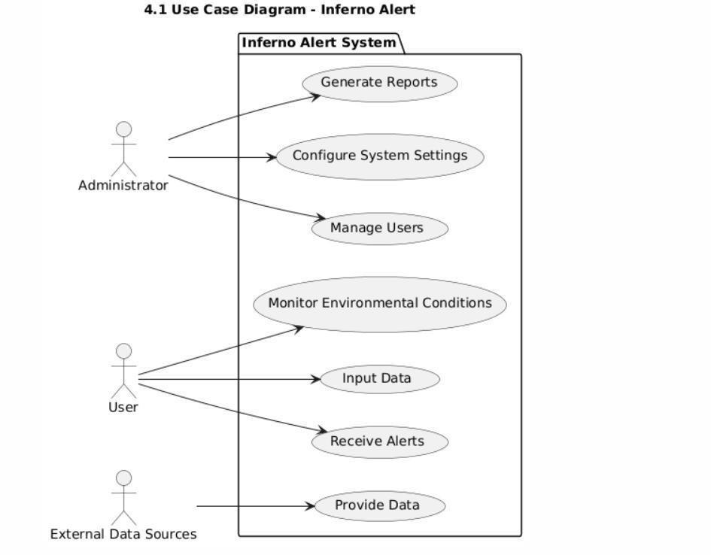

## 4.2 Data Flow Diagram

The data flow diagram (DFD) illustrates how data moves through the Fireguardian system, from data collection to processing and alert generation. It provides a clear view of the system's data processes and interactions.

### 4.2.1 Components of the DFD

* **External Entities**:
* **Users**: Input data regarding occupancy and activities.
* **APIs**: Provide real-time data.
* **Building Management Systems (BMS)**: Supply data on occupancy levels and environmental conditions.
* **Data Collection**: Gathers data from users, APIs, and BMS.
* **Data Processing**: Analyzes collected data using machine learning algorithms to identify potential fire hazards.
* **Alert Generation**: Triggers alerts based on processed data and predefined thresholds.
* **User Data Store**: Stores user profiles and preferences.
* **Historical Data Store**: Maintains records of past incidents, environmental data, and user inputs.
* **Machine Learning Model**: Contains the trained model used for fire prediction.

### 4.2.2 Data Flow Description

1. **Data Collection**:
   * Users input data regarding occupancy and activities, which is sent to the Data Collection process.
   * APIs provide real-time data to the Data Collection process.
   * BMS sends data on occupancy levels and environmental conditions to the Data Collection process.
2. **Data Processing**:
   * The Data Collection process forwards the gathered data to the Data Processing process.
   * The Data Processing process analyzes the data using the machine learning model to identify potential fire hazards.
3. **Alert Generation**:
   * If a potential fire hazard is detected, the Data Processing process triggers the Alert Generation process.
   * Alerts are sent to users via notifications, and relevant data is stored in the Historical Data Store for future reference.

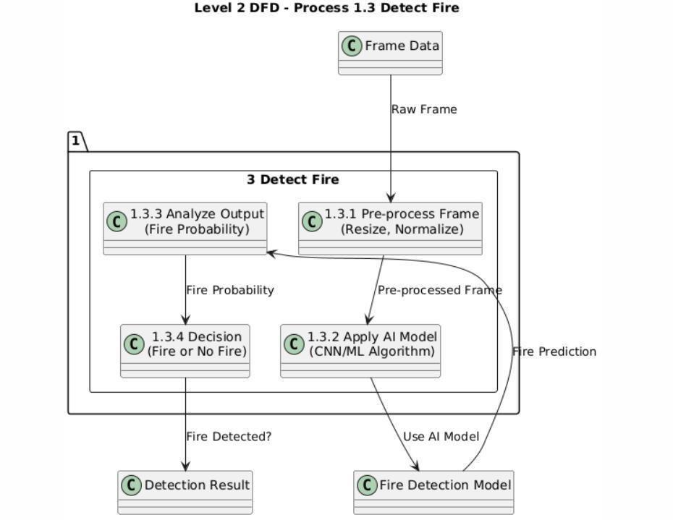 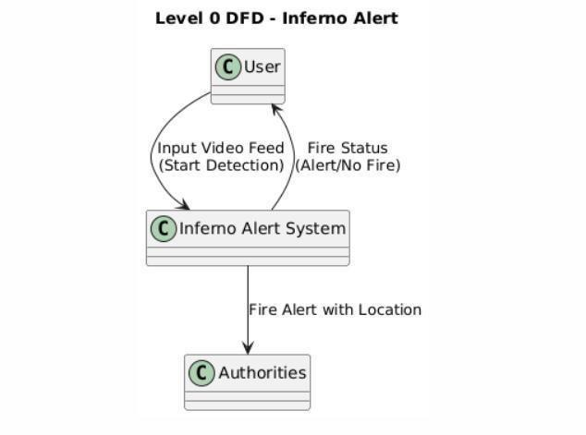

Level-1 DFD

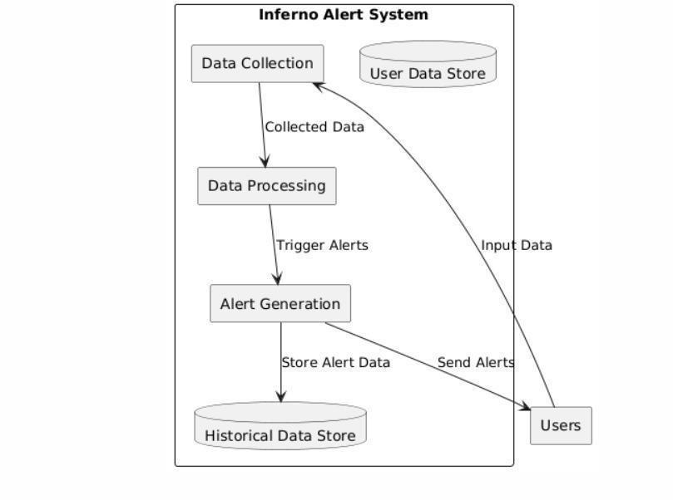

## 4.3 Class Diagram

The class diagram outlines the structure of the Fireguardian system, including the classes that represent different components of the system. It provides a blueprint for the system's architecture and relationships between classes.

**4.3.1 Classes and Attributes** 1. **User **:

* **Attributes**:
* **user_id**: Unique identifier for the user.
* **username**: User's login name.
* **password**: User's password (hashed for security).
* **role**: User's role (e.g., admin, regular user).
* **Methods**:
* **login()**: Authenticates the user.
* **logout()**: Logs the user out of the system.
* **updateProfile()**: Updates user information.

1. **Alert**:
   * **Attributes**:
   * **alert_id**: Unique identifier for the alert.
   * **timestamp**: Time when the alert was generated.
   * **alert_type**: Type of alert (e.g., fire risk, environmental anomaly).
   * **message**: Description of the alert.
   * **Methods**:
   * **sendAlert()**: Sends the alert to users.
   * **acknowledgeAlert()**: Marks the alert as acknowledged by the user.
2. **DataCollector**:
   * **Attributes**:
   * **data_source**: Source of the data (e.g., user input).
   * **data**: Collected data (temperature, humidity, occupancy).
   * **Methods**:
   * **collectData()**: Gathers data from various sources.
   * **validateData()**: Validates the collected data for accuracy.
3. **DataProcessor**:
   * **Attributes**:
   * **model**: Machine learning model used for analysis.
   * **Methods**:
   * **processData()**: Analyzes the collected data.
   * **predictFireRisk()**: Uses the model to predict potential fire hazards.
4. **HistoricalDataStore**:
   * **Attributes**:
   * **data_records**: List of historical data records.
   * **Methods**:
   * **storeData()**: Saves data to the historical data store.
   * **retrieveData()**: Retrieves historical data for analysis.
5. **Fireguardian API**:
   * + **Attributes**:
     + **api_key**: API key for accessing data.
     + **Methods**:
     + **fetchData()**: Retrieves real-time data.
     + **parseData()**: Parses the received data for use in the system.

### 4.3.2 Class Diagram Relationships

* **Associations**:
* The **User ** class has a one-to-many relationship with the **Alert** class, as a user can receive multiple alerts.
* The **DataCollector** class interacts with the **BMS** classes to gather data.
* The **DataProcessor** class uses the **DataCollector** to obtain data for analysis.
* The **HistoricalDataStore** class is used by both the **DataCollector** and **DataProcessor** to store and retrieve data.

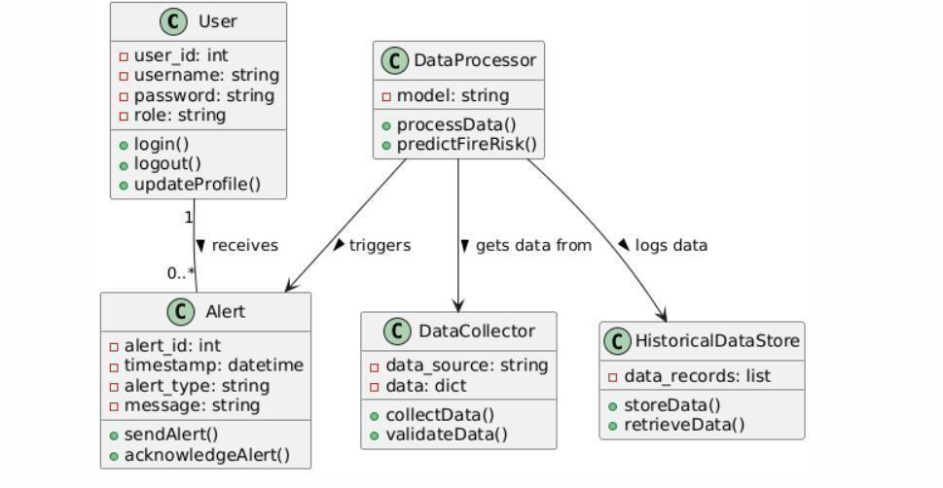

## 4.4 Activity Diagram for Fireguardian Alert System 1. Start

The system is initialized. 

1. **Monitor Environment**

Sensors detect temperature, smoke, and other indicators of fire. 

1. **Data Collection**

Collect data from various sensors (temperature, smoke, etc.). 

1. **Analyze Data**
   * + Check if the data exceeds predefined thresholds.
     + **Decision Point: Is there a fire?**
     + **Yes:** Proceed to the next step.
     + **No:** Return to "Monitor Environment."
2. **TriggerAlert**
   * Activate alarm systems (audible alarms, flashing lights).
   * Notify emergency services (fire department).
   * Send alerts to registered users (via SMS, email, app notifications).
3. **Evacuation Protocol**
   * Initiate evacuation procedures if necessary.
   * Provide instructions to users (e.g., exit routes).
4. **Monitor Fire Response**

 Track the response of emergency services. 

Update users on the status of the situation.

1. **End**

* System returns to monitoring mode after the situation is resolved. **Visual Representation**

To create a visual representation of this activity diagram, you would typically use UML software or drawing tools. Here’s a simple way to visualize it:

* **Start** (Oval)
* **Monitor Environment** (Rectangle)
* **Data Collection** (Rectangle)
* **Analyze Data** (Rectangle) **Decision Point** (Diamond) **Is there a fire?** 
* **Yes** (Arrow to "Trigger Alert")
* **No** (Arrow back to "Monitor Environment")
* **TriggerAlert** (Rectangle)
* **Evacuation Protocol** (Rectangle)
* **Monitor Fire Response** (Rectangle)
* **End** (Oval)

**Notes**

* Each activity can be further detailed with sub-activities if necessary.
* The decision points can include more conditions based on the system's complexity.
* The diagram can also include swimlanes to represent different actors (e.g., sensors, users, emergency services) involved in the process.

This activity diagram provides a high-level overview of how an Fireguardian System operates,

from monitoring the environment to responding to a fire alert

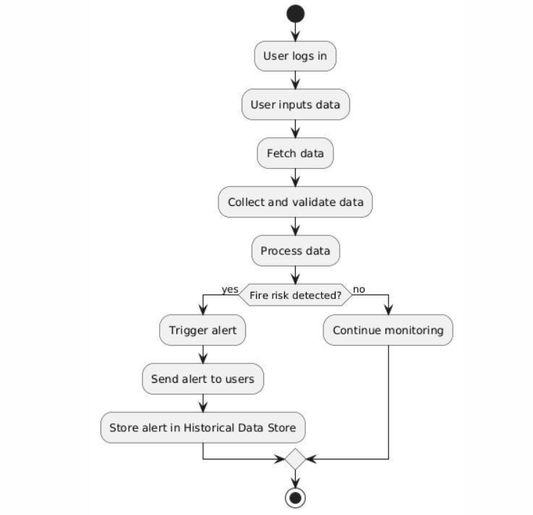

# CHAPTER 5 - USER INTERFACE DESCRIPTION & DESIGN

## 5.1 Input Screen Designs with Data

The input screens are critical for user interaction, allowing users to enter essential data regarding building occupancy, environmental conditions, and historical incidents. Each screen is designed to be intuitive and user-friendly, ensuring that users can input data quickly and accurately.

### 5.1.1 Building Occupancy Input Screen

Purpose: This screen allows users to report the current occupancy levels and activities within the building.

**Key Features:**

* Current Occupancy Field: A numeric input field where users can enter the number of people currently in the building. This field should have validation to ensure that only positive integers are accepted.
* Activity Type Dropdown: A dropdown menu that allows users to select the type of activity occurring in the building, such as "Normal Operations," "Cooking,"

"Maintenance," or "Event."

* Comments Text Area: A larger text area for users to provide additional context or notes about the occupancy situation, such as specific events or unusual circumstances.
* Submit Button: A button labeled "Submit" that saves the entered data to the system.
* Cancel Button: A button labeled "Cancel" that allows users to discard their input and return to the previous screen.

### 5.1.2 Environmental Conditions Input Screen

Purpose: This screen enables users to input real-time environmental data, which is crucial for assessing fire risk.

**Key Features:**

* Temperature Field: A numeric input field for entering the current temperature, with options to select the unit (Celsius or Fahrenheit). Validation should ensure that the input is within a reasonable range.
* Humidity Field: A numeric input field for entering the current humidity percentage, with validation to ensure values are between 0 and 100.
* Additional Conditions Checkboxes: Checkboxes for other environmental factors that may indicate fire risk, such as "Smoke Detected" or "Unusual Odors."
* Submit Button: A button labeled "Submit" to save the entered environmental data. • Cancel Button: A button labeled "Cancel" to discard changes and return to the previous screen

### 5.1.3 Historical Incidents Input Screen

Purpose: This screen allows users to report historical fire incidents and related data.

**Key Features:**

* Incident Date Picker: A date picker for selecting the date of the incident, ensuring that users can easily choose the correct date.
* Incident Description Text Area: A text area for users to describe the incident, including details about causes, effects, and outcomes.
* Response Actions Dropdown: A dropdown menu to select the response actions taken during the incident, such as "Evacuated," "Called Fire Department," or

"Extinguished."

* Submit Button: A button labeled "Submit" to save the incident report to the system. • Cancel Button: A button labeled "Cancel" to discard changes and return to the previous screen.

## 5.2 Report Layout Designs & Running Screens with Data

The report layout is designed to present data analysis results, alerts, and historical trends in a clear and user-friendly format. This section focuses on the dashboard overview and detailed report layout.

### 5.2.1 Dashboard Overview

Purpose: The dashboard provides users with a summary of key metrics and alerts at a glance, allowing for quick assessment of the current situation.

**Key Features:**

* Header: A prominent header displaying " Fireguardian Dashboard."
* Key Metrics Display: Sections showing:
* Current Occupancy: Displays the number of people currently in the building. • Average Temperature: Shows the average temperature recorded over a specified period.
* Current Alerts: Indicates the number of active alerts, with a link to view

details.

* Alerts Section: A dedicated area that lists active alerts with timestamps and descriptions, allowing users to quickly understand any immediate risks.
* Historical Trends Graphs: Visual representations (graphs or charts) showing historical data trends, such as temperature changes over time or occupancy levels during specific periods.
* Navigation Menu: A sidebar or top navigation menu with links to other sections of the system, such as "Input Data," "Reports," and "Settings."5.2.2 Detailed Report Layout

Purpose: The detailed report layout presents comprehensive reports on historical incidents, alerts, and environmental data, allowing users to analyze trends and outcomes.

**Key Features:**

* Header: A header labeled "Detailed Reports."
* Filter Options: Dropdowns or checkboxes to filter reports by date range, incident type, or alert type, enabling users to customize the data they view.
* Report Table: A structured table displaying report data with columns for:
* Date: The date of the incident or alert.
* Incident Description: A brief description of the incident.
* Response Actions: Actions taken in response to the incident.
* Status: Current status of the incident (e.g., Resolved, Ongoing).
* Export Options: Buttons to export the report as a PDF or CSV file, allowing users to download and share the data easily.
* Back Button: A button to return to the dashboard or previous screen, ensuring easy navigation.

# CHAPTER 6 - SYSTEM TESTING,

**IMPLEMENTATION, AND MAINTENANCE**

In this chapter, we will delve into the processes involved in testing the Fireguardian system, the implementation plan for deploying the system, and the strategies for ongoing maintenance. Each of these components is critical to ensuring that the system operates effectively and continues to meet user needs over time.

## 6.1 Testing

### 6.1.1 Overview & Approach

Testing is a vital phase in the software development life cycle (SDLC) that ensures the system meets its requirements and functions as intended. The testing process for the Fireguardian system will encompass various types of testing to validate functionality, performance, security, and usability.

**Objectives of Testing**:

* To identify and fix defects before the system goes live.
* To ensure that the system meets specified requirements and user expectations.
* To verify that the system performs well under expected load conditions.
* To ensure that the system is secure and protects user data.

**Testing Types**:

1. **Unit Testing**:
   * Focuses on individual components or modules of the system. Each function or method will be tested in isolation to ensure it behaves as expected.
   * Automated testing frameworks (e.g., JUnit for Java, pytest for Python) will be used to facilitate unit testing.
   * Example: Testing the **processData()** method in the DataProcessor class to ensure it correctly analyzes input data.
2. **Integration Testing**:
   * Tests the interaction between different modules and components of the system. This ensures that integrated components work together correctly.
   * Scenarios will be created to simulate real-world interactions between modules, such as data flow from the DataCollector to the DataProcessor.
   * Example: Testing the integration between the DataCollector and the API to ensure that data is correctly fetched and processed.
3. **System Testing**:
   * Involves testing the complete and integrated system to verify that it meets the specified requirements. This includes functional testing, performance testing, and security testing.
   * Functional testing will validate that all features work as intended, while performance testing will assess the system's responsiveness and stability under load.
   * Example: Conducting a load test to simulate multiple users accessing the system simultaneously and measuring response times.
4. **User Acceptance Testing (UAT)**:
   * Conducted by end-users to validate that the system meets their needs and expectations. UAT will be performed in a controlled environment that mimics the production setting.
   * Feedback from users during UAT will be collected to identify any issues or areas for improvement before the final deployment.
   * Example: Users will test the input screens and report any difficulties in data entry or navigation.
5. **Regression Testing**:

* Performed after changes or updates to the system to ensure that existing functionality remains unaffected. Automated regression tests will be run to verify that previously tested features still work correctly.
* Example: After a new feature is added, running a suite of regression tests to ensure that existing functionalities, such as alert generation, still operate as expected.

**Testing Approach**:

* A comprehensive test plan will be developed outlining the scope, objectives, resources, schedule, and deliverables for the testing process.
* Test cases will be created for each type of testing, detailing the input, expected output, and execution steps.
* A bug tracking system (e.g., JIRA, Bugzilla) will be used to log and manage any defects identified during testing, ensuring that they are addressed before deployment.
* Regular testing meetings will be held to review progress, discuss issues, and adjust testing strategies as needed.

## 6.2 System Implementation Plan

The implementation plan outlines the steps required to deploy the Fireguardian system into a production environment. This plan ensures a smooth transition from development to operational use.

**Implementation Steps**:

1. **Preparation**:
   * Finalize the system design and ensure all components are developed and tested.
   * Prepare the production environment, including server setup, database configuration, and network configurations.
   * Conduct a risk assessment to identify potential challenges during implementation and develop mitigation strategies.
2. **Data Migration**:
   * If applicable, migrate any existing data from legacy systems to the new Fireguardian system. This may involve data cleansing and transformation to ensure compatibility.
   * Validate the migrated data to ensure accuracy and completeness.
3. **Deployment**:
   * + Deploy the system to the production environment. This may involve:
     + Installing the application on the server.
     + Configuring the database and ensuring connectivity.
     + Setting up external data sources
     + Conduct smoke testing post-deployment to verify that the system is operational and that critical functionalities are working.
4. **User Training**:
   * Conduct training sessions for users to familiarize them with the system's features and functionalities. Training materials, such as user manuals and video tutorials, will be provided.
   * Offer hands-on training sessions where users can practice using the system in a controlled environment.
5. **Go-Live**:
   * Officially launch the system for use by end-users. Monitor the system closely during the initial go-live period to address any issues that arise.
   * Establish a support hotline or helpdesk for users to report issues or seek assistance during the initial rollout.
6. **Post-Implementation Review**:
   * Conduct a review after the system has been live for a specified period (e.g., 30 days). Gather feedback from users and stakeholders to assess the system's performance and identify any areas for improvement.
   * Document lessons learned and best practices for future implementations.

## 6.3 System Maintenance

Ongoing maintenance is essential to ensure the Fireguardian system remains functional, secure, and up-to-date. A maintenance plan will be established to address the following aspects:

**Maintenance Activities**:

1. **Regular Updates**:
   * + Implement software updates to address bugs, security vulnerabilities, and performance improvements. This includes updating libraries, frameworks, and dependencies used in the system.
     + Schedule regular maintenance windows to apply updates and perform system checks without disrupting user activities.
2. **Monitoring and Support**:
   * + Continuously monitor system performance and user activity to identify any issues or anomalies. Use monitoring tools (e.g., New Relic, Grafana) to track system health and performance metrics.
     + A support team will be available to assist users with any questions or problems they encounter. Establish a ticketing system for users to report issues and track resolution progress.
3. **Backup and Recovery**:
   * + Establish a backup strategy to ensure that data is regularly backed up and can be restored in case of data loss or system failure. This may involve automated backups of the database and application files.
     + Conduct periodic disaster recovery drills to test the effectiveness of the backup and recovery procedures.
4. **User Feedback**:
   * + Regularly collect feedback from users to identify areas for improvement and new feature requests. This feedback will inform future updates and enhancements to the system.
     + Conduct user satisfaction surveys to gauge user experience and identify pain points.
5. **Documentation**:
   * Maintain up-to-date documentation for the system, including user manuals, technical specifications, and maintenance procedures. This documentation will be essential for onboarding new team members and ensuring continuity.
   * Create a knowledge base or FAQ section to help users troubleshoot common issues independently.
6. **Performance Reviews**:
   * Conduct periodic performance reviews to assess the system's effectiveness and efficiency. This may involve analyzing usage metrics, response times, and user satisfaction levels.
   * Use performance data to identify trends and make informed decisions about future enhancements or optimizations.

**CHAPTER 7- CODING AND SCREENSHORTS**

**Main.py**

from flask import Flask, render_template, redirect, url_for, request, flash, jsonify from flask_sqlalchemy import SQLAlchemy from flask_wtf import FlaskForm from flask_login import (

LoginManager, UserMixin, login_user, login_required, logout_user, current_user

)

from wtforms import StringField, PasswordField, TextAreaField from wtforms.validators import InputRequired, Length, EqualTo, Email from werkzeug.security import generate_password_hash, check_password_hash from flask_admin import Admin

from flask_admin.contrib.sqla import ModelView from datetime import datetime, timezone import subprocess import os app = Flask(__name__)

# ————— Database Configuration —————

db_path = os.path.join(app.root_path, 'instance', 'user.db') os.makedirs(os.path.dirname(db_path), exist_ok=True) app.config['SQLALCHEMY_DATABASE_URI'] = f'sqlite:///{db_path}' app.config['SECRET_KEY'] = 'your_secret_key' app.config['SQLALCHEMY_TRACK_MODIFICATIONS'] = False db = SQLAlchemy(app)

# ————— Login Manager —————

login_manager = LoginManager(app) login_manager.login_view = 'login'# ————— Models ————— class User(UserMixin, db.Model):

id

= db.Column(db.Integer, primary_key=True)

email = db.Column(db.String(100), unique=True, nullable=False) password = db.Column(db.String(100), nullable=False) class Contact(db.Model):

id

= db.Column(db.Integer, primary_key=True) name = db.Column(db.String(150), nullable=False) email = db.Column(db.String(150), nullable=False) message = db.Column(db.Text, nullable=False) class Location(db.Model):

id

= db.Column(db.Integer, primary_key=True) city

= db.Column(db.String(100), nullable=False) region = db.Column(db.String(100), nullable=False) location = db.Column(db.String(255), nullable=False) timestamp = db.Column( db.DateTime(timezone=True), nullable=False,

default=lambda: datetime.now(timezone.utc)

)

@login_manager.user_loader def load_user(user_id):

return User.query.get(int(user_id))

# ————— Admin Panel —————

admin = Admin(app, name='Database Admin',

template_mode='bootstrap3')admin.add_view(ModelView(User, db.session)) admin.add_view(ModelView(Contact, db.session)) admin.add_view(ModelView(Location, db.session))

# ————— Forms ————— class SignUpForm(FlaskForm):

email

= StringField('Email', validators=[InputRequired(), Email(), Length(3,100)]) password

= PasswordField('Password', validators=[InputRequired(), Length(min=6)]) confirm_password = PasswordField('Confirm Password', validators=[InputRequired(), EqualTo('password')]) class LoginForm(FlaskForm):

email = StringField('Email', validators=[InputRequired(), Email(), Length(3,100)]) password = PasswordField('Password', validators=[InputRequired()]) class ContactForm(FlaskForm):

name = StringField('Name', validators=[InputRequired(), Length(2,100)]) email = StringField('Email', validators=[InputRequired(), Email(), Length(3,100)]) message = TextAreaField('Message', validators=[InputRequired(), Length(10,500)])

# ————— Routes —————

@app.route('/') def home():

return render_template('home.html')

@app.route('/about') def about():

return render_template('about.html')

@app.route('/faq')

def faq():return render_template('faq.html') @app.route('/contact', methods=['GET','POST']) def contact():

form = ContactForm() if form.validate_on_submit(): msg = Contact(name=form.name.data, email=form.email.data, message=form.message.data) db.session.add(msg) db.session.commit()

flash("Your message has been sent!", "success") return redirect(url_for('contact'))

return render_template('contact.html', form=form) @app.route('/signup', methods=['GET','POST']) def signup():

form = SignUpForm() if form.validate_on_submit(): if User.query.filter_by(email=form.email.data).first():

flash("Email already exists!", "danger") else:

user = User( email=form.email.data,

password=generate_password_hash(form.password.data, 'sha256')

)

db.session.add(user) db.session.commit()

flash("Account created!", "success") return redirect(url_for('login'))

return render_template('signup.html', form=form)@app.route('/login', methods=['GET','POST']) def login():

form = LoginForm()

if form.validate_on_submit():

user = User.query.filter_by(email=form.email.data).first() if user and check_password_hash(user.password, form.password.data):

login_user(user)

return redirect(url_for('dashboard')) flash("Invalid credentials", "danger") return render_template('login.html', form=form)

@app.route('/dashboard') @login_required def dashboard():

return render_template('dashboard.html', user=current_user)

@app.route('/save_location', methods=['POST']) def save_location():

data = request.get_json() if 'error' in data:

return jsonify(message=f"Error: {data['error']}"), 400 try:

ts = data.get('timestamp') if isinstance(ts, str):

ts = datetime.strptime(ts, "%Y-%m-%d %H:%M:%S").replace(tzinfo=timezone.utc) else:

ts = datetime.now(timezone.utc) loc = Location(

city=data['city'],region=data['region'], location=data['location'], timestamp=ts

)

db.session.add(loc)

db.session.commit()

return jsonify(message="Location saved successfully"), 200 except Exception as e: return jsonify(message=f"Failed to save location: {e}"), 500

@app.route('/location') def location():

history = Location.query.order_by(Location.timestamp.desc()).all() return render_template('location.html', locations=history)

@app.route('/run_model') @login_required def run_model(): try:

subprocess.Popen(["python", "fire_detection_alert_system.py"]) flash("? Fire detection started!", "success") except Exception as e:

flash(f"Error starting detection: {e}", "danger") return redirect(url_for('dashboard'))

@app.route('/logout') @login_required def logout():

logout_user()flash("Logged out.", "info") return redirect(url_for('login'))

# ————— Main ————— if __name__ == '__main__': with app.app_context(): db.create_all() app.run(debug=True)

**Fire_detection_alert_system.py**

import warnings

warnings.filterwarnings("ignore", category=FutureWarning) import cv2 import torch import pygame import requests

from datetime import datetime, timezone import pytz

# ——— Settings ———

API_URL

= "http://127.0.0.1:5000/save_location"

FIRE_THRESHOLD = 10

TIMEZONE_STR = 'Asia/Kolkata' # adjust if needed

# ——— Initialize siren ——— pygame.mixer.init()

siren_sound = pygame.mixer.Sound('siren.mp3')

# ——— Load your YOLOv5 model ———model = torch.hub.load(

'ultralytics/yolov5',

'custom', path=r'C:\Users\disha\OneDrive\Desktop\fire_detection_project\yolov5\runs\train\custom_ model22\weights\best.pt'

)

# ——— Video capture ———

video1 = cv2.VideoCapture(0) if not video1.isOpened():

print("Error: Could not access the camera.") exit()

# ——— State ———

fire_frames = 0 siren_playing = False

# ——— Helpers ——— def get_geo_location():

"""Fetch city, region, lat/long via IP.""" try:

info = requests.get('https://ipinfo.io/json').json() return {

"city": info.get("city", "Unknown"),

"region": info.get("region", "Unknown"),

"loc": info.get("loc", "0,0")

}

except Exception as e:

print("⚠ Geo lookup failed:", e)

return {"city": "Unknown", "region": "Unknown", "loc": "0,0"}def send_location_to_server(city, region, loc, timestamp): """POST the detection data to the Flask backend.""" payload = { "city": city,

"region": region,

"location": loc,

"timestamp": timestamp

} try:

resp = requests.post(API_URL, json=payload) print(f"→ POST {payload} -> {resp.status_code}", resp.text) except Exception as e:

print("❌ Error sending location:", e) def get_local_timestamp():

"""Return a timezone-aware string timestamp.""" tz = pytz.timezone(TIMEZONE_STR) now = datetime.now(tz) return now.strftime("%Y-%m-%d %H:%M:%S")

# ——— Main Loop ——— while True:

ret, frame = video1.read() if not ret:

print("Error: Could not read frame") break # Run inference results = model(frame)

preds = results.pandas().xywh[0]fire_detected = any( (row['name']=="fire" and row['confidence']>0.5) for _, row in preds.iterrows()

)

# Update consecutive fire frames fire_frames = fire_frames + 1 if fire_detected else 0 # If threshold passed and siren not yet playing, trigger if fire_frames > FIRE_THRESHOLD and not siren_playing:

print("? Fire detected!") siren_sound.play(-1) siren_playing = True

# Fetch geolocation + timestamp and send to Flask geo

= get_geo_location()

timestamp = get_local_timestamp() send_location_to_server( city=geo["city"], region=geo["region"], loc=geo["loc"], timestamp=timestamp

)

# If no fire, stop siren

#if not fire_detected and siren_playing:

# print("? No fire — stopping siren.")

# siren_sound.stop()

# siren_playing = False# Display annotated frame results.render()

cv2.imshow("Fire Detection", frame) key = cv2.waitKey(1) & 0xFF if key == ord('q'):

break # Cleanup cv2.destroyAllWindows() video1.release() **Models.py**

from flask_sqlalchemy import SQLAlchemy from flask_login import UserMixin from sqlalchemy.sql import func

from werkzeug.security import generate_password_hash, check_password_hash from wtforms.validators import Email from datetime import datetime, timezone db = SQLAlchemy()

# User Model class User(db.Model, UserMixin):

id = db.Column(db.Integer, primary_key=True)

email = db.Column(db.String(150), unique=True, nullable=False) password = db.Column(db.String(150), nullable=False)

# Ensures password is hashed def set_password(self, password):

self.password = generate_password_hash(password)

# Verifies password

def check_password(self, password):return check_password_hash(self.password, password)

# Note Model class Note(db.Model):

id = db.Column(db.Integer, primary_key=True) data = db.Column(db.String(10000))

date = db.Column(db.DateTime(timezone=True), default=func.now()) updated_at = db.Column(db.DateTime(timezone=True), default=func.now(), onupdate=func.now()) # Automatically updated when modified user_id = db.Column(db.Integer, db.ForeignKey('user.id'))

# Contact Model class Contact(db.Model):

id = db.Column(db.Integer, primary_key=True) name = db.Column(db.String(150), nullable=False)

email = db.Column(db.String(150), nullable=False, unique=True) # Email must be unique message = db.Column(db.Text, nullable=False)

created_at = db.Column(db.DateTime(timezone=True), default=func.now()) # Custom email validation method (if needed, use it in forms or controllers) def validate_email(self): if not Email()(self.email):

raise ValueError('Invalid email format')

# Constructor for Contact (you may choose to move email validation to form-level) def __init__(self, name, email, message):

self.name = name self.email = email self.message = message self.validate_email()class Location(db.Model): id = db.Column(db.Integer, primary_key=True) city = db.Column(db.String(100), nullable=False) region = db.Column(db.String(100), nullable=False) location = db.Column(db.String(255), nullable=False)

timestamp = db.Column(db.DateTime(timezone=True), default=func.now())

__table_args__ = (db.UniqueConstraint('city', 'region', 'location', name='unique_location'),) def __init__(self, city, region, location, timestamp=None):

self.city = city self.region = region self.location = location

self.timestamp = timestamp or datetime.now(timezone.utc) **routes.py**

from flask import Blueprint, render_template main = Blueprint('main', __name__) # ✅ Define once!

@main.route('/') def home():

return render_template('home.html')

@main.route('/about') def about():

return render_template('about.html') # Ensure about.html exists in templates

folder@main.route('/faq')

def faq():

return render_template('faq.html') # Ensure faq.html exists

@main.route('/contact') # ✅Add this route

def contact():

return render_template('contact.html') # Ensure contact.html exists in templates

@main.route('/run_model', methods=['POST']) def run_model():

# your model loading and prediction code here return "Model ran successfully!" **Auth.py**

from flask import Blueprint, render_template, request, flash, redirect, url_for from .models import User from . import db

from werkzeug.security import generate_password_hash, check_password_hash from .forms import SignupForm, LoginForm # Import the forms auth = Blueprint('auth', __name__)

@auth.route('/signup', methods=['GET', 'POST']) def signup():

form = SignupForm() # Create an instance of SignupForm if form.validate_on_submit(): # Validate the form user = User.query.filter_by(email=form.email.data).first() if user:

flash('Email already exists.', category='error') else:

new_user=User(email=form.email.data,password=generate_password_hash(form.password.

data, method='sha256'))db.session.add(new_user) db.session.commit()

flash('Account created successfully!', category='success')

return redirect(url_for('auth.login'))

return render_template('signup.html', form=form) # Pass form to template

@auth.route('/login', methods=['GET', 'POST']) def login():

form = LoginForm() # Create an instance of LoginForm if form.validate_on_submit(): # Validate form user = User.query.filter_by(email=form.email.data).first() if user and check_password_hash(user.password, form.password.data):

flash('Logged in successfully!', category='success') return redirect(url_for('main.home')) # Redirect to the home page else:

flash('Incorrect email or password.', category='error')

return render_template('login.html', form=form) # Pass form to template **Main.py**

from website import create_app app = create_app() if __name__ == '__main__': app.run(debug=True)**requirements.txt**

Flask==2.2.5

Flask-Login==0.6.2

Flask-SQLAlchemy==3.0.5 Werkzeug==2.2.3

gunicorn==21.2.0 # If deploying to a server flask-wtf==1.1.1 # For handling forms securely **about.html**

<!DOCTYPE html>

<html lang="en">

<head>

<meta charset="UTF-8">

<title>About Us – Fireguardian Alert</title>

<meta name="viewport" content="width=device-width, initial-scale=1">

<style>

/* RESET & BASE */

* { margin:0; padding:0; box-sizing:border-box; } html, body { height:100vh; overflow:hidden; /* no scrollbars */ font-family:'Segoe UI', Tahoma, Geneva, Verdana, sans-serif; display:flex; align-items:center; justify-content:center; background: url("{{ url_for('static', filename='images/home.png') }}") no-repeat center center fixed; background-size:cover;

} .overlay {

position:absolute; top:0; left:0; right:0; bottom:0; background:rgba(0,0,0,0.6);}

/* CARD CONTAINER */

.about-container { position:relative; z-index:2; width:90%; max-width:800px; height:90vh; /* fit within viewport */ background:rgba(0,0,0,0.75); border-radius:12px; padding:20px 25px;

/* tighter padding */ box-shadow:0 0 25px rgba(0,255,255,0.5); backdrop-filter:blur(4px); text-align:center; display:flex;

/* flex column to distribute content */ flex-direction:column; justify-content:space-between; /* distribute sections evenly */

}

/* ANIMATIONS */

@keyframes fadeInUp {

from { opacity:0; transform:translateY(20px); } to { opacity:1; transform:translateY(0); }

}

@keyframes slideInLeft { from { opacity:0; transform:translateX(-30px); } to { opacity:1; transform:translateX(0); }

}

/* HEADINGS & TEXT */

h1 {font-size:2.2rem; color:#00ffff; margin-bottom:10px; text-shadow:1px 1px 4px rgba(0,0,0,0.8); animation:slideInLeft 1s ease-out;

}

h2 { font-size:1.5rem; color:#ffee33; margin:12px 0 6px; animation:fadeInUp 1s ease-out both; } p, ul { font-size:0.9rem; color:#ddd; line-height:1.4; animation:fadeInUp 1s ease-out both;

} ul { list-style:none; padding-left:0; } ul li { margin:4px 0; }

.tagline { font-size:1rem; font-weight:600; margin-top:10px; animation:fadeInUp 1s ease-out both;

}

</style>

</head>

<body>

<div class="overlay"></div>

<div class="about-container">

<div>

<h1>About Us</h1><p><strong> Fireguardian </strong> is an advanced fire detection system designed to enhance safety and prevent fire hazards in homes, offices, and industrial areas. Using cutting- edge AI and real-time monitoring, we ensure quick detection and alert authorities instantly.</p>

</div>

<div>

<h2>Our Mission</h2>

<p>We aim to minimize fire-related damages and save lives by providing an efficient, automated fire detection solution.</p>

</div>

<div>

<h2>What We Offer</h2>

<ul>

<li>• <strong>Real-Time Fire Detection</strong> – AI-powered image processing for immediate alerts.</li>

<li>• <strong>Instant Notifications</strong> – Get alerts via Siren, Email, or App.</li>

</ul>

</div>

<div>

<h2>Why Choose Fireguardian ?</h2>

<ul>

<li>✔AI-Powered Accuracy</li>

<li>✔ 24/7 Monitoring</li>

<li>✔ User-Friendly Dashboard</li>

<li>✔ Scalable for Any Space</li>

</ul>

</div>

<p class="tagline">? Stay Safe. Stay Fireguardian </p>

</div> </body> </html>**Base.html**

<!DOCTYPE html>

<html lang="en">

<head>

<meta charset="UTF-8">

<meta name="viewport" content="width=device-width, initial-scale=1.0">

<title>{% block title %} Fireguardian {% endblock %}</title>

<!-- Bootstrap CSS -->

<link href="https://cdn.jsdelivr.net/npm/bootstrap@5.3.0/dist/css/bootstrap.min.css" rel="stylesheet">

<!-- Custom CSS -->

<link rel="stylesheet" href="{{ url_for('static', filename='css/style.css') }}">

<!-- Font Awesome for Icons -->

<link rel="stylesheet" href="https://cdnjs.cloudflare.com/ajax/libs/font-awesome/6.0.0- beta3/css/all.min.css">

</head>

<body class="bg-dark text-white">

<!-- Navbar -->

<nav class="navbar navbar-expand-lg navbar-dark bg-danger">

<div class="container">

<a class="navbar-brand fw-bold fs-2" href="/"><i class="fas fa-fire"></i>

Fireguardian </a>

<button class="navbar-toggler" type="button" data-bs-toggle="collapse" data-bs target="#navbarNav">

<span class="navbar-toggler-icon"></span>

</button>

<div class="collapse navbar-collapse" id="navbarNav">

<ul class="navbar-nav ms-auto"><li class="nav-item"><a class="nav-link fs-4" href="/"><i class="fas fa- home"></i> Home</a></li>

<li class="nav-item"><a class="nav-link fs-4" href="/about"><i class="fas fa info-circle"></i> About Us</a></li>

<li class="nav-item"><a class="nav-link fs-4" href="/faq"><i class="fas fa- question-circle"></i> FAQs</a></li>

<li class="nav-item"><a class="nav-link fs-4" href="/contact"><i class="fas fa- phone-alt"></i> Contact Us</a></li>

<a href="{{ url_for('logout') }}" class="btn btn-outline-light fs-4"><i class="fas fa-sign-out-alt"></i> Logout</a>

</ul>

</div>

</div>

</nav>

<!-- Main Content -->

<div class="container mt-5">

{% block content %}

{% endblock %}

</div>

<!-- Footer -->

<footer class="text-center mt-5 py-3 bg-danger text-dark">

<p class="mb-0 fs-5">© 2025 Fireguardian | All Rights Reserved</p>

</footer>

<!-- Bootstrap JS -->

<script src="https://cdn.jsdelivr.net/npm/bootstrap@5.3.0/dist/js/bootstrap.bundle.min.js"></script> </body>

</html>**Contact.html**

<!DOCTYPE html>

<html lang="en">

<head>

<meta charset="UTF-8">

<meta name="viewport" content="width=device-width, initial-scale=1.0">

<title>Contact Us - FitFusion</title>

<!-- Inline CSS -->

<style> body { margin: 0; padding: 0; font-family: 'Segoe UI', Tahoma, Geneva, Verdana, sans-serif; background: url('/static/images/home.png') no-repeat center center fixed; background-size: cover; display: flex; justify-content: center; align-items: center; height: 100vh;

} .container { display: flex; justify-content: center; align-items: center; width: 100%; padding: 20px; }.form-box {

background: rgba(0, 0, 0, 0.85); padding: 40px 30px; border-radius: 12px; box-shadow: 0 0 30px rgba(0, 191, 255, 0.6); width: 100%; max-width: 420px;

color: #fff;

}

/* Change h2 to h1 and center it */

.form-box h1 { text-align: center; /* Center the heading */ margin-bottom: 10px; font-weight: 700; color: #fff; text-shadow: 1px 1px 4px rgba(0, 0, 0, 0.8);

}

.form-box p { text-align: center; color: #ccc; font-size: 14px; margin-bottom: 25px;

}

.form-group { margin-bottom: 20px; }.form-label { display: block; margin-bottom: 6px; font-weight: 500; color: #ccc; } .form-control { width: 100%; padding: 12px 15px; border-radius: 8px; border: none; font-size: 15px; color: #000; background-color: #fff; box-sizing: border-box;

} textarea.form-control { resize: none; } .btn-submit { width: 100%; padding: 12px; background-color: #00c8d7; border: none; border-radius: 8px; color: white; font-weight: bold;font-size: 16px; cursor: pointer; transition: background 0.3s;

}

.btn-submit:hover { background-color: #009eaa;

}

</style>

</head>

<body>

<div class="container">

<div class="form-box">

<h1>Contact Us</h1> <!-- Changed h2 to h1 and centered it -->

<p>We’d love to hear from you. Please fill out this form.</p>

<form method="POST">

{{ form.hidden_tag() }}

<div class="form-group">

{{ form.name.label(class="form-label") }}

{{ form.name(class="form-control", placeholder="Your full name") }}

</div>

<div class="form-group">

{{ form.email.label(class="form-label") }}

{{ form.email(class="form-control", placeholder="example@email.com") }}

</div>

<div class="form-group">{{ form.message.label(class="form-label") }} {{ form.message(class="form-control", placeholder="Type your message here...", rows="4") }}

</div>

<div class="form-group">

<button type="submit" class="btn-submit">Send Message</button>

</div>

</form>

</div>

</div>

</body>

</html>

**Dashboard.html**

{% extends "base.html" %}

{% block content %}

<style> body { background: url("{{ url_for('static', filename='images/home.png') }}") no-repeat center center fixed;

background-size: cover;

}

.dashboard-box { max-width: 480px; margin: 80px auto; background: rgba(0, 0, 0, 0.85); padding: 40px 35px;border-radius: 12px; box-shadow: 0 0 30px rgba(0, 191, 255, 0.6); text-align: center; color: #fff; }

.btn-primary { display: inline-block; background-color: #544caf; color: white; padding: 12px 30px; text-decoration: none; border-radius: 18px; margin: 10px 0; font-size: 1rem;

}

.btn-primary:hover { background-color: #45a049;

}

</style>

<div class="dashboard-box">

<h2><i class="fas fa-fire"></i> Fire Detection</h2>

<!-- Start Detection Button -->

<a href="{{ url_for('run_model') }}" class="btn-primary">

<i class="fas fa-flame"></i> Start Detection

</a><!-- View History Button -->

<a href="{{ url_for('location') }}" class="btn-primary">

<i class="fas fa-history"></i> View Detection History

</a>

</div> {% endblock %}

**Faq.html**

<!DOCTYPE html>

<html lang="en">

<head>

<meta charset="UTF-8" />

<meta name="viewport" content="width=device-width, initial-scale=1.0"/>

<title>FAQs - Fireguardian </title>

<link

href="https://cdn.jsdelivr.net/npm/bootstrap@5.3.0/dist/css/bootstrap.min.css" rel="stylesheet"/>

<style> body, html { height: 100%; margin: 0; padding: 0; overflow: hidden; background: url("{{ url_for('static', filename='images/home.png') }}") no-repeat center center fixed; background-size: cover; font-family: 'Segoe UI', sans-serif;

color: whitesmoke;

}

.faq-box {width: 90%; max-width: 900px; height: 90vh; margin: 5vh auto; background: rgba(0, 0, 0, 0.7); border-radius: 15px; padding: 40px; box-shadow: 0 0 30px rgba(0, 123, 255, 0.6); overflow-y: auto;

}

.faq-box h1 { text-align: center; font-weight: bold; margin-bottom: 40px; /* ← increased */

} .accordion { margin-top: 10px;

/* ← added */

}

.accordion-button { font-weight: bold; background-color: #fdf6d9 !important; color: darkcyan !important;

}

.accordion-body { background-color: white; color: lightseagreen;} .contact-footer { text-align: center; font-size: 18px; margin-top: 30px;

}

.btn-contact { margin-top: 10px;

}

@media (max-width: 768px) {

.faq-box { padding: 20px; height: 95vh;

}

}

</style>

</head>

<body>

<div class="faq-box">

<h1>Frequently Asked Questions</h1>

<div class="accordion" id="faqAccordion">

<!-- Q1 -->

<div class="accordion-item">

<h2 class="accordion-header">

<button class="accordion-button" type="button" data-bs-toggle="collapse" data-bs target="#faq1">

How does Fireguardian detect fires?</button>

</h2>

<div id="faq1" class="accordion-collapse collapse">

<div class="accordion-body">

Fireguardian uses AI-based flame detection and live monitoring to alert users in real-time. </div>

</div>

</div>

<!-- Q2 -->

<div class="accordion-item">

<h2 class="accordion-header">

<button class="accordion-button collapsed" type="button" data-bs-toggle="collapse" data-bs-target="#faq2">

Can I use this system for my home?

</button>

</h2>

<div id="faq2" class="accordion-collapse collapse">

<div class="accordion-body">

Yes, it is designed for both home and commercial use.

</div>

</div>

</div>

<!-- Q3 -->

<div class="accordion-item">

<h2 class="accordion-header">

<button class="accordion-button collapsed" type="button" data-bs-toggle="collapse" data-bs-target="#faq3">

Does it require internet to work?</button>

</h2>

<div id="faq3" class="accordion-collapse collapse">

<div class="accordion-body">

It works offline for detection, but internet is needed for remote notifications.

</div>

</div>

</div>

<!-- Q4 -->

<div class="accordion-item">

<h2 class="accordion-header">

<button class="accordion-button collapsed" type="button" data-bs-toggle="collapse" data-bs-target="#faq4">

Can it differentiate between fire and other bright objects?

</button>

</h2>

<div id="faq4" class="accordion-collapse collapse">

<div class="accordion-body">

Yes, the AI model is trained to distinguish fire from lights or sunlight.

</div>

</div>

</div>

<!-- Q5 -->

<div class="accordion-item">

<h2 class="accordion-header">

<button class="accordion-button collapsed" type="button" data-bs-toggle="collapse" data-bs-target="#faq5">

What’s the installation process like?

</button></h2>

<div id="faq5" class="accordion-collapse collapse">

<div class="accordion-body">

The system is plug-and-play with simple camera placement instructions.

</div>

</div>

</div>

<!-- Q6 -->

<div class="accordion-item">

<h2 class="accordion-header">

<button class="accordion-button collapsed" type="button" data-bs-toggle="collapse" data-bs-target="#faq6">

Can I use it in outdoor areas?

</button>

</h2>

<div id="faq6" class="accordion-collapse collapse">

<div class="accordion-body">

Yes, it's effective in open areas like parking lots, gardens, etc.

</div>

</div>

</div>

<!-- Q7 -->

<div class="accordion-item">

<h2 class="accordion-header">

<button class="accordion-button collapsed" type="button" data-bs-toggle="collapse" data-bs-target="#faq7">

How accurate is the detection?

</button>

</h2><div id="faq7" class="accordion-collapse collapse">

<div class="accordion-body">

The detection model has a high accuracy rate of 95%+ under tested conditions.

</div>

</div>

</div>

<!-- Q8 -->

<div class="accordion-item">

<h2 class="accordion-header">

<button class="accordion-button collapsed" type="button" data-bs-toggle="collapse" data-bs-target="#faq8">

Will it notify emergency services?

</button>

</h2>

<div id="faq8" class="accordion-collapse collapse">

<div class="accordion-body">

That feature is under development. Currently, alerts are sent to registered users only.

</div>

</div>

</div>

</div>

<div class="contact-footer">

<p>If you have more queries, feel free to reach out!</p>

<a href="/contact" class="btn btn-primary btn-contact">Contact Us</a>

</div> </div><script src="https://cdn.jsdelivr.net/npm/bootstrap@5.3.0/dist/js/bootstrap.bundle.min.js"></script> </body>

</html>

**Home.html**

<!DOCTYPE html>

<html lang="en">

<head>

<meta charset="UTF-8">

<meta name="viewport" content="width=device-width, initial-scale=1">

<title> Fireguardian - Smart Fire Detection</title>

<!-- Bootstrap CSS -->

<link

href="https://cdn.jsdelivr.net/npm/bootstrap@5.3.0/dist/css/bootstrap.min.css" rel="stylesheet">

<!-- Font Awesome -->

<link rel="stylesheet" href="https://cdnjs.cloudflare.com/ajax/libs/font-awesome/5.15.4/css/all.min.css" /> <style> body, html { height: 100%; margin: 0; font-family: 'Segoe UI', Tahoma, Geneva, Verdana, sans-serif; }

.hero {background: url("{{ url_for('static', filename='images/home.png') }}") no-repeat center center/cover; height: 100vh; position: relative; overflow: hidden; color: white;

}

.overlay { background: rgba(0, 0, 0, 0.6); position: absolute; width: 100%; height: 100%; z-index: 1; }

.header { position: absolute; top: 20px; left: -100%; font-size: 40px; font-weight: bold; color: #FF5733; text-shadow: 3px 3px 6px rgba(0, 0, 0, 0.7); text-transform: uppercase; z-index: 2; animation: slideIn 1s forwards, fadeInText 2s ease-out;

}

@keyframes slideIn {

100% { left: 40px; }}

@keyframes fadeInText {

0% { opacity: 0; }

100% { opacity: 1; }

} .nav-links { position: absolute; top: 20px;

right: 40px; z-index: 2; animation: fadeInNav 2s ease-out;

} .nav-links a { color: white; margin-left: 25px; text-decoration: none; font-weight: 500; font-size: 18px;

transition: color 0.3s ease, transform 0.3s ease; display: inline-flex; align-items: center; } .nav-links a i { margin-right: 8px; font-size: 1.1em;

}

.nav-links a:hover { color: #FF5733; transform: scale(1.1);} .content { position: relative; z-index: 2; top: 50%; transform: translateY(-50%); text-align: center; padding: 0 20px;

} .content h1 { font-size: 50px; margin-bottom: 20px;

} .content p { font-size: 20px; margin-bottom: 30px; color: #ddd;

}

.btn-custom { background-color: #FF5733; color: white; font-size: 18px; padding: 12px 28px; border-radius: 50px; text-decoration: none; box-shadow: 0 4px 10px rgba(0, 0, 0, 0.25); transition: background 0.3s, transform 0.3s, box-shadow 0.3s;

}.btn-custom:hover { background-color: #d4411e; transform: translateY(-5px); box-shadow: 0 6px 14px rgba(0, 0, 0, 0.3);

} .footer { position: absolute; bottom: 50px; width: 100%; text-align: center; z-index: 2;

}

@keyframes fadeInNav {

0% { opacity: 0; transform: translateX(20px); }

100% { opacity: 1; transform: translateX(0); }

}

@media (max-width: 768px) {

.header { font-size: 36px; left: 20px; }

.nav-links a { font-size: 16px; margin-left: 15px; }

.content h1 { font-size: 34px; }

.content p { font-size: 16px; }

}

</style>

</head>

<body>

<div class="hero">

<div class="overlay"></div><div class="header"> Fireguardian </div>

<div class="nav-links">

<a href="{{ url_for('home') }}"><i class="fas fa-home"></i>Home</a>

<a href="{{ url_for('about') }}"><i class="fas fa-info-circle"></i>About Us</a>

<a href="{{ url_for('faq') }}"><i class="fas fa-question-circle"></i>FAQs</a>

<a href="{{ url_for('contact') }}"><i class="fas fa-phone-alt"></i>Contact Us</a>

</div>

<div class="content">

<h1>Smart Fire Detection System</h1>

<p>Stay alert and safe with real-time fire monitoring & response technology.</p>

</div>

<div class="footer">

<a href="{{ url_for('login') }}" class="btn btn-custom">Get Started</a>

</div>

</div>

</body>

</html>

**Login.html**

<!DOCTYPE html>

<html lang="en">

<head>

<meta charset="UTF-8">

<meta name="viewport" content="width=device-width, initial-scale=1.0">

<title>Login | Fireguardian </title>

<!-- Bootstrap CSS --><link

href="https://cdn.jsdelivr.net/npm/bootstrap@5.3.0/dist/css/bootstrap.min.css" rel="stylesheet">

<style> body { background: url("{{ url_for('static', filename='images/home.png') }}") no-repeat center center fixed; background-size: cover; display: flex; justify-content: center; align-items: center; height: 100vh; margin: 0; font-family: 'Segoe UI', Tahoma, Geneva, Verdana, sans-serif; }

.form-box { width: 400px; background: rgba(0, 0, 0, 0.7); padding: 40px; border-radius: 15px; box-shadow: 0 0 30px rgba(0, 123, 255, 0.6); color: #fff; }

.form-box h2 { text-align: center; margin-bottom: 30px; color:whitesmoke; font-weight: bold; font-size: 28px; }.form-label { color: #ddd;

}

.form-control { background-color: rgba(255, 255, 255, 0.1); border: none; border-radius: 8px; color: #fff;

}

.form-control::placeholder { color: #ccc;

}

.form-control:focus { background-color: rgba(255, 255, 255, 0.2); color: #fff; box-shadow: none;

}

.btn-custom { background-color: #00ffff; color: #000; font-weight: bold; transition: all 0.3s ease-in-out;

}

.btn-custom:hover { background-color: #00bfbf; color: #000;transform: scale(1.05);

}

a.text-primary { color: #00ffff !important;

}

a.text-primary:hover { text-decoration: underline;

}

</style>

</head>

<body>

<div class="form-box">

<h2>Login</h2>

{% with messages = get_flashed_messages(with_categories=true) %}

{% if messages %}

{% for category, message in messages %}

<div class="alert alert-{{ category }} text-center" role="alert">

{{ message }}

</div>

{% endfor %}

{% endif %}

{% endwith %}

<form method="POST">

{{ form.hidden_tag() }}

<div class="mb-3"><label class="form-label">Email:</label>

{{ form.email(class="form-control", placeholder="Enter your email") }}

</div>

<div class="mb-3">

<label class="form-label">Password:</label>

{{ form.password(class="form-control", placeholder="Enter your password") }} </div>

<button type="submit" class="btn btn-custom w-100 mt-3">Login</button>

</form>

<p class="mt-4 text-center">

Don’t have an account? <a href="{{ url_for('signup') }}" class="text-primary">Sign up</a> </p>

</div>

<!-- Bootstrap JS -->

<script src="https://cdn.jsdelivr.net/npm/bootstrap@5.3.0/dist/js/bootstrap.bundle.min.js"></script> </body> </html> **signup.html**

<!DOCTYPE html>

<html lang="en">

<head>

<meta charset="UTF-8">

<meta name="viewport" content="width=device-width, initial-scale=1.0">

<title>Sign Up | Fireguardian </title>

<!-- Bootstrap CSS --><link

href="https://cdn.jsdelivr.net/npm/bootstrap@5.3.0/dist/css/bootstrap.min.css" rel="stylesheet">

<style> body { background: url("{{ url_for('static', filename='images/home.png') }}") no-repeat center center fixed; background-size: cover; display: flex; justify-content: center; align-items: center; height: 100vh; margin: 0; font-family: 'Segoe UI', Tahoma, Geneva, Verdana, sans-serif; }

.form-box { width: 400px;

background: rgba(0, 0, 0, 0.7); padding: 40px; border-radius: 15px; box-shadow: 0 0 30px rgba(0, 123, 255, 0.6); color: #fff;

}

.form-box h2 { text-align: center; margin-bottom: 30px; color: whitesmoke; font-weight: bold; font-size: 28px;} .form-label { color: #ddd;

}

.form-control { background-color: rgba(255, 255, 255, 0.1); border: none; border-radius: 8px; color: #fff;

}

.form-control::placeholder { color: #ccc;

}

.form-control:focus { background-color: rgba(255, 255, 255, 0.2); color: #fff; box-shadow: none;

}

.btn-custom { background-color: #00ffff; color: #000; font-weight: bold; transition: all 0.3s ease-in-out; }.btn-custom:hover { background-color: #00bfbf; color: #000; transform: scale(1.05);

}

a.text-primary { color: #00ffff !important;

}

a.text-primary:hover { text-decoration: underline;

}

.text-danger small { color: #ff8080;

}

</style>

</head>

<body>

<div class="form-box">

<h2>Sign Up</h2>

<!-- Flash Messages -->

{% with messages = get_flashed_messages(with_categories=true) %}

{% if messages %}

{% for category, message in messages %}

<div class="alert alert-{{ category }} alert-dismissible fade show" role="alert"> {{ message }}<button type="button" class="btn-close" data-bs-dismiss="alert" aria label="Close"></button>

</div>

{% endfor %}

{% endif %}

{% endwith %}

<form method="POST">

{{ form.hidden_tag() }}

<div class="mb-3">

<label class="form-label">Email:</label>

{{ form.email(class="form-control", placeholder="Enter your email") }}

{% if form.email.errors %}

<div class="text-danger">

{% for error in form.email.errors %}

<small>{{ error }}</small>

{% endfor %}

</div>

{% endif %}

</div>

<div class="mb-3">

<label class="form-label">Password:</label>

{{ form.password(class="form-control", placeholder="Enter your password") }}

{% if form.password.errors %}

<div class="text-danger">

{% for error in form.password.errors %}

<small>{{ error }}</small>

{% endfor %}

</div>{% endif %}

</div>

<div class="mb-3">

<label class="form-label">Confirm Password:</label>

{{ form.confirm_password(class="form-control", placeholder="Re-enter your password") }}

{% if form.confirm_password.errors %}

<div class="text-danger">

{% for error in form.confirm_password.errors %}

<small>{{ error }}</small>

{% endfor %}

</div>

{% endif %}

</div>

<button type="submit" class="btn btn-custom w-100">Sign Up</button>

</form>

<p class="mt-3 text-center">

Already have an account? <a href="{{ url_for('login') }}" class="text- primary">Login</a>

</p>

</div>

<!-- Bootstrap JS -->

<script src="https://cdn.jsdelivr.net/npm/bootstrap@5.3.0/dist/js/bootstrap.bundle.min.js"></script> </body>

</html>

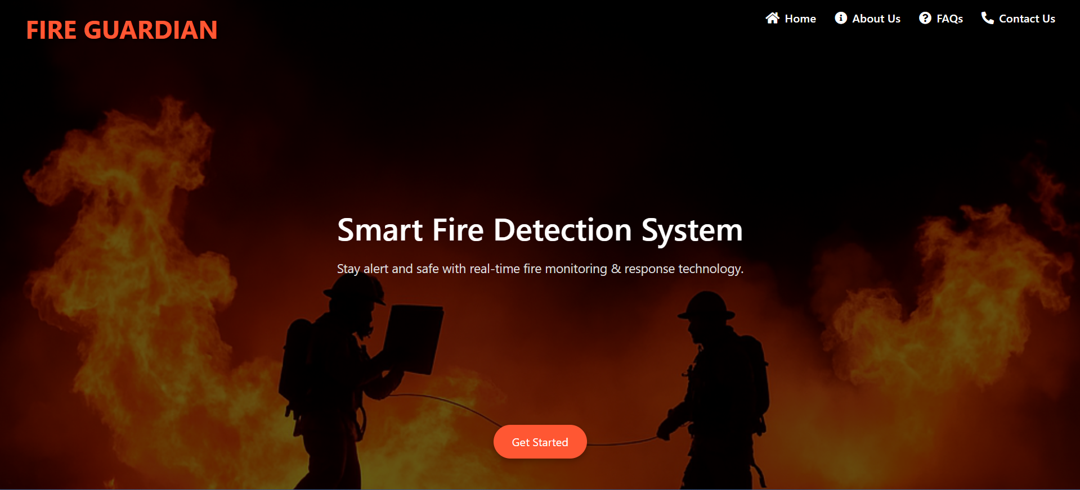

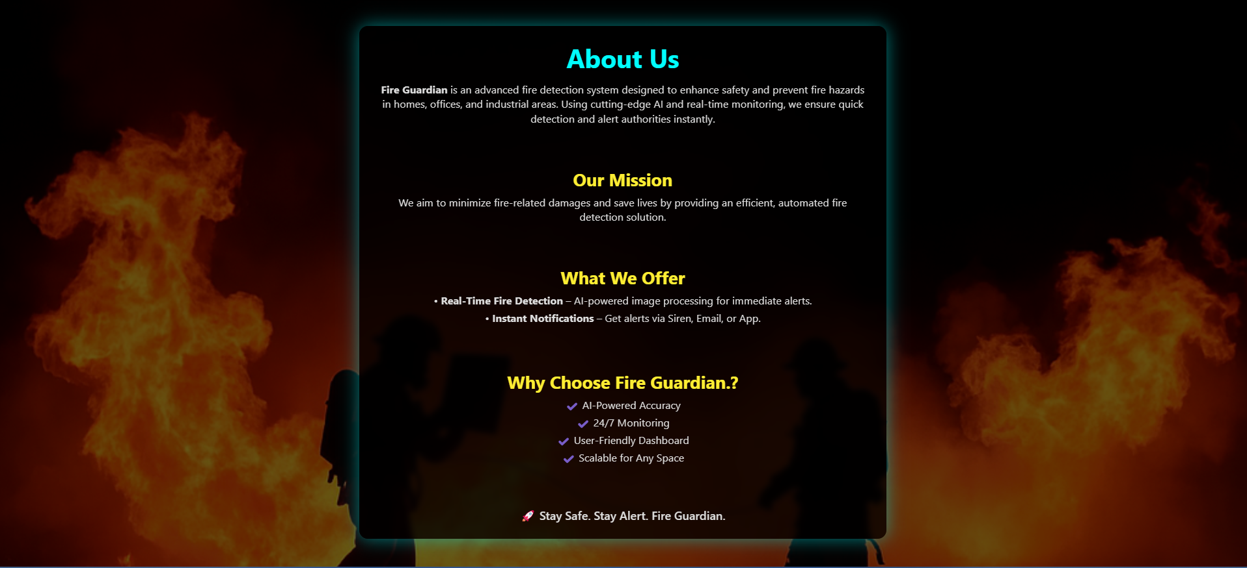

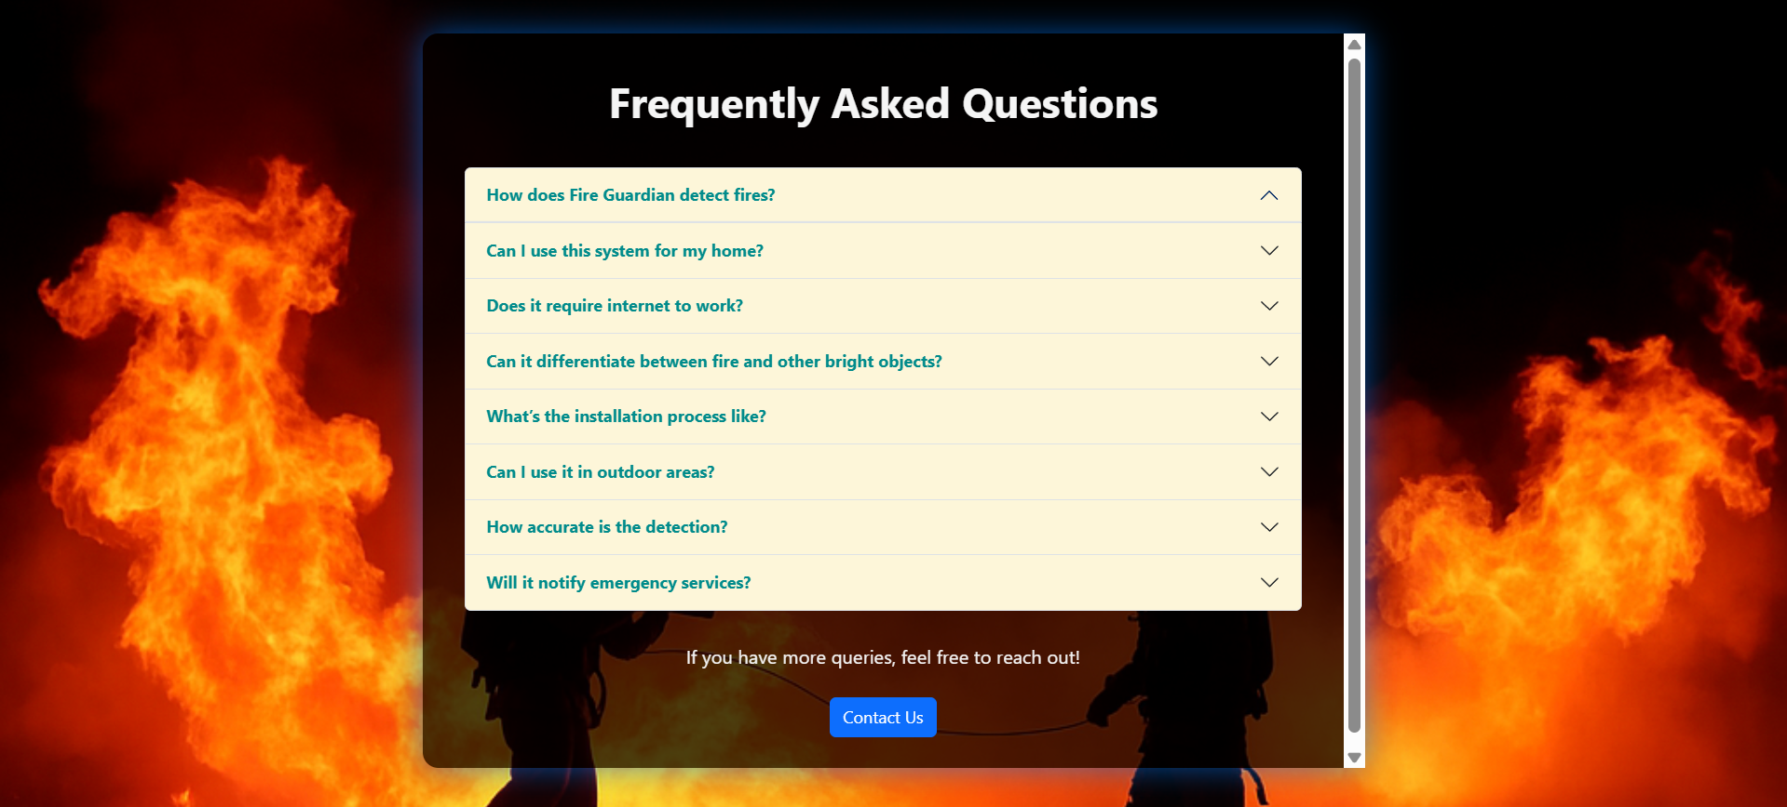



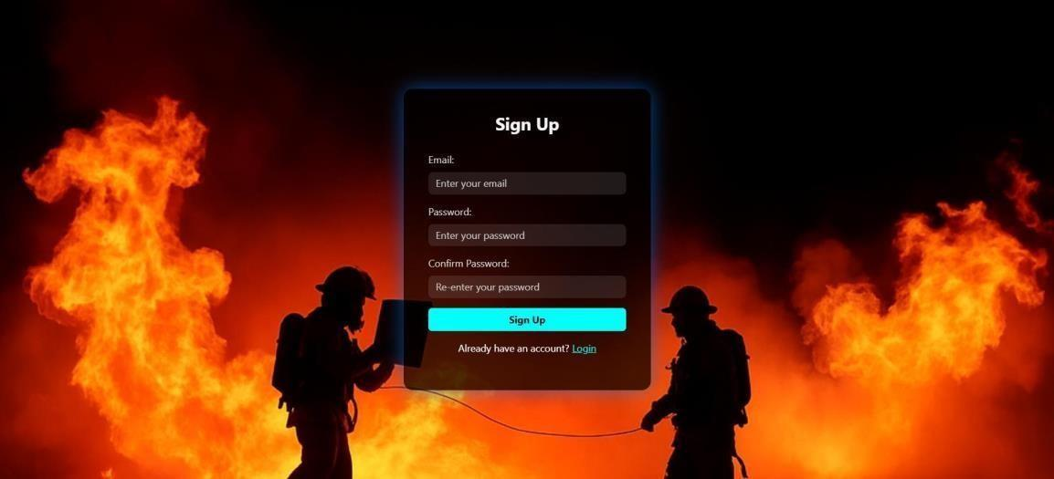

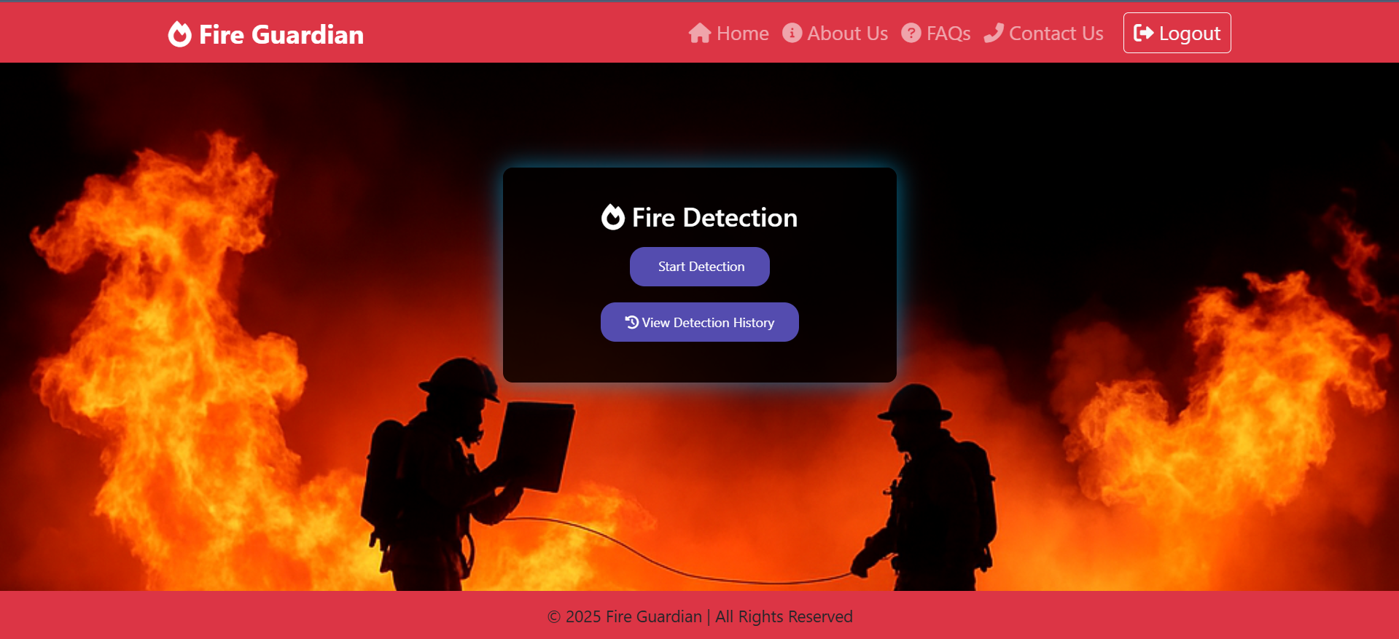

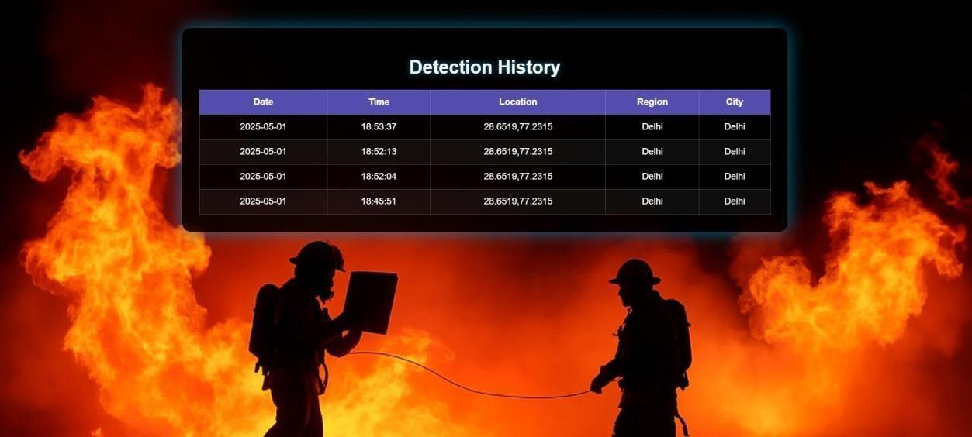

## DATABASE



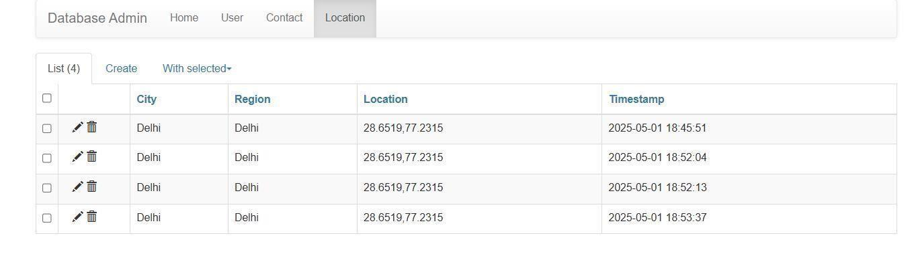

# CHAPTER 8 - CONCLUSION, LIMITATIONS, AND FUTURE SCOPE

In this chapter, we will summarize the key findings and contributions of the Fireguardian system, discuss its limitations, and outline potential future developments and enhancements. This comprehensive overview will provide insights into the system's effectiveness and areas for improvement.

## 8.1 Conclusion

The Fireguardian system represents a significant advancement in fire detection and safety management, leveraging modern technology to enhance the effectiveness of fire prevention strategies. The following key conclusions can be drawn from the development and implementation of the system:

1. **Proactive Fire Risk Management**:

• The system's ability to analyze real-time environmental data, combined with historical incident reports, allows for more accurate predictions of fire risks. By identifying potential hazards before they escalate, the Fireguardian system can facilitate timely interventions, potentially saving lives and property. For instance, if the system detects a combination of high temperatures and low humidity levels, it can issue alerts to building occupants and management to take preventive measures.

1. **User -Centric Design**:
   * The user interface has been designed with a focus on usability and accessibility. This ensures that users, regardless of their technical expertise, can easily navigate the system, input data, and access critical information. The inclusion of training materials and support resources further enhances user experience and promotes effective system adoption. User feedback during the testing phase indicated high satisfaction with the interface, which contributed to a smoother onboarding process.
2. **Comprehensive Reporting and Analytics**:
   * The reporting features of the Fireguardian system provide valuable insights into historical trends, incident responses, and system performance. Users can generate detailed reports that aid in evaluating fire safety protocols and making informed decisions. For example, organizations can analyze incident reports to identify patterns, such as frequent incidents occurring during specific times or conditions, allowing them to adjust their safety measures accordingly.
3. **Scalability and Flexibility**:
   * The system is designed to be scalable, allowing for integration with various external data sources and building management systems. This flexibility ensures that the system can adapt to different environments, whether in residential, commercial, or industrial settings, making it a versatile solution for fire safety management. The ability to integrate with IoT devices and existing infrastructure enhances its applicability across diverse scenarios.
4. **Community Impact**:
   * By improving fire detection and response capabilities, the Fireguardian system has the potential to positively impact community safety. Organizations that implement the system can contribute to a safer environment, reducing the risk of fire-related incidents and enhancing overall public safety. For instance, local fire departments can benefit from the data collected by the system, allowing them to allocate resources more effectively during emergencies.
5. **Cost-Effectiveness**:
   * The Fireguardian system can lead to significant cost savings for organizations by reducing false alarms and minimizing the need for extensive physical fire detection infrastructure. By leveraging data analytics and machine learning, the system can optimize resource allocation and improve response times, ultimately leading to lower operational costs.

In conclusion, the Fireguardian system demonstrates the potential of technology to improve fire safety management, providing organizations with the tools they need to enhance their safety protocols and protect lives and property.

## 8.2 Limitations

While the Fireguardian system offers numerous benefits, it is essential to acknowledge its limitations, which may affect its overall effectiveness:

1. **Dependence on Data Quality**:
   * The accuracy of the machine learning model and the effectiveness of the alerts are heavily reliant on the quality and completeness of the data collected. Inaccurate or incomplete data can lead to false positives (unnecessary alerts) or missed alerts (failure to detect actual risks), undermining the system's reliability. For example, if environmental sensors malfunction or provide erroneous readings, the system may issue alerts that do not reflect the actual conditions.
2. **Integration Challenges**:
   * Integrating the system with existing building management systems and external data sources may present technical challenges. Compatibility issues, varying data formats, and the need for custom APIs can complicate the integration process, potentially delaying deployment and increasing costs. Organizations may need to invest in additional resources or expertise to facilitate these integrations.
3. **User Training Requirements**:
   * Although the system is designed to be user-friendly, effective utilization still requires adequate training. Users may face a learning curve, particularly if they are not familiar with technology or data entry processes. Insufficient training can lead to data entry errors and underutilization of the system's features. Ongoing training sessions and refresher courses may be necessary to ensure users remain proficient.
4. **Regulatory Compliance**:
   * The system must comply with local fire safety regulations and standards, which may vary by region. Ensuring compliance can be complex and may require ongoing adjustments to the system. Organizations must stay informed about regulatory changes to maintain compliance, which can involve additional administrative overhead.
5. **Resource Constraints**:
   * Organizations may face budgetary or resource constraints that limit their ability to implement and maintain the system effectively. This can impact the overall effectiveness of the fire safety management strategy, particularly in smaller organizations with limited resources. Organizations may need to prioritize funding for training, maintenance, and system upgrades.
6. **Potential for Over-Reliance on Technology**:
   * While the system enhances fire safety management, there is a risk that users may become overly reliant on technology. It is essential to maintain a balance between automated alerts and human judgment in fire safety decision-making. Users should be trained to recognize the limitations of the system and to respond appropriately to alerts.
7. **Cybersecurity Risks**:
   * As a technology-driven solution, the Fireguardian system may be vulnerable to cybersecurity threats. Unauthorized access to the system could compromise sensitive data or disrupt operations. Implementing robust security measures, such as encryption and access controls, is essential to mitigate these risks.

## 8.3 Future Scope

The future scope of the Fireguardian system encompasses several potential developments and enhancements that can further improve its functionality and effectiveness:

1. **Advanced Machine Learning Algorithms**:

Future iterations of the system can explore the use of more sophisticated machine learning algorithms, such as deep learning techniques, to improve the accuracy of fire risk predictions. This could involve training models on larger datasets, including diverse environmental conditions and historical incidents, 

to enhance their predictive capabilities. For example, incorporating patterns and seasonal variations could lead to more accurate risk assessments.

1. **Integration with IoT Devices**:

• Expanding the system's integration with Internet of Things (IoT) devices, such as smart smoke detectors, temperature sensors, and environmental monitoring devices, can provide real-time data and enhance the system's ability to detect potential fire hazards. This integration can lead to more comprehensive monitoring and quicker response times. For instance, IoT devices could automatically trigger alerts based on real-time sensor data.

1. **Mobile Application Development**:

• Developing a mobile application for the Fireguardian system can enhance accessibility and allow users to receive alerts and notifications on-the-go. A mobile app can also facilitate data entry and provide users with real-time updates, improving engagement and responsiveness. Features such as push notifications and location-based alerts can further enhance user experience.

1. **Enhanced User Training Programs**:
   * Implementing more robust user training programs, including interactive tutorials, simulations, and gamified learning experiences, can help users become more proficient in using the system. This can lead to better data entry practices and more effective utilization of the system's features. Regular training updates can ensure users are aware of new features and best practices.
2. **Data Analytics and Visualization**:
   * Future versions of the system can incorporate advanced data analytics and visualization tools to provide users with deeper insights into fire safety trends and performance metrics. Interactive dashboards and visual reports can aid organizations in making data-driven decisions regarding their fire safety protocols. For example, heat maps showing areas of frequent incidents can help prioritize safety measures.
3. **Collaboration with Fire Safety Authorities**:
   * Establishing partnerships with local fire safety authorities and organizations can enhance the system's credibility and effectiveness. Collaborating on data sharing, incident reporting, and community outreach can lead to improved community safety and response strategies. Joint training programs and awareness campaigns can further strengthen community engagement.
4. **Regular Updates and Maintenance**:
   * Ongoing updates to the system, including security patches, feature enhancements, and performance optimizations, will be essential to ensure that it remains effective and secure. A dedicated maintenance team can help address any issues that arise and implement user feedback for continuous improvement.

Regular audits of the system can help identify areas for enhancement.

1. **Research and Development**:
   * Continued research into emerging technologies, such as artificial intelligence and machine learning, can lead to innovative enhancements in fire detection and prevention strategies. Exploring new methodologies and technologies can keep the Fireguardian system at the forefront of fire safety management. Collaborating with academic institutions or research organizations can facilitate this exploration.
2. **Community Engagement and Awareness**:
   * Developing community engagement initiatives to raise awareness about fire safety and the capabilities of the Fireguardian system can enhance its impact. Workshops, seminars, and informational campaigns can educate the public about fire risks, prevention strategies, and the importance of timely reporting.
   * **Public Demonstrations**: Organizing public demonstrations of the Fireguardian system can showcase its features and effectiveness. This can help build trust within the community and encourage organizations to adopt the system.
   * **Partnerships with Local Organizations**: Collaborating with local schools, businesses, and community organizations can facilitate outreach efforts. Educational programs can be tailored to different audiences, emphasizing the importance of fire safety and how the Fireguardian system can contribute to a safer environment.
   * **Feedback Mechanisms**: Establishing channels for community feedback can help improve the system and its implementation. Community members can provide insights into their experiences with fire safety, which can inform future enhancements to the system.
3. **Integration with Emergency Response Systems**:
   * Future developments could include integration with local emergency response systems, such as fire departments and emergency medical services. This integration can facilitate real-time communication and coordination during fire incidents.
   * **Automated Alerts to Authorities**: The system could be designed to automatically notify local fire departments when certain thresholds are met (e.g., multiple alerts triggered in a short period). This can ensure that emergency responders are prepared and can act quickly.
   * **Data Sharing for Incident Analysis**: Collaborating with emergency response teams to share data on incidents can enhance situational awareness and improve response strategies. Analyzing incident data collectively can lead to better resource allocation and training for first responders.
4. **Enhanced Security Features**:
   * As the system evolves, it will be essential to implement enhanced security features to protect against cyber threats. This includes regular security audits, penetration testing, and the adoption of best practices for data protection.
   * **User Authentication and Access Control**: Implementing multi-factor authentication (MFA) and role-based access control (RBAC) can help secure user accounts and sensitive data. Ensuring that only authorized personnel have access to critical system functions is vital for maintaining data integrity.
   * **Incident Response Plan**: Developing a comprehensive incident response plan to address potential security breaches will be crucial. This plan should outline procedures for detecting, responding to, and recovering from security incidents.
5. **Sustainability and Environmental Considerations**:

* Future iterations of the Fireguardian system can explore sustainability initiatives, such as energy-efficient data processing and environmentally friendly hardware solutions. This aligns with growing concerns about environmental impact and corporate social responsibility.
* **Green Technology Integration**: Investigating the use of renewable energy sources for powering system components, such as servers and sensors, can contribute to a more sustainable operation. This can also enhance the system's appeal to environmentally conscious organizations.

# CHAPTER 9 - REFERENCES

In this chapter, we will provide a comprehensive list of references that were utilized throughout the development of the Fireguardian system. These references include academic papers, books, articles, websites, and other resources that contributed to the research, design, implementation, and evaluation of the system. Proper citation of these sources is essential for acknowledging the contributions of other authors and for providing readers with the opportunity to explore the topics further.

**9.1 Books Fire Safety**

**Management Handbook**

Author: Daniel E. Della-Giustina

Publisher: CRC Press

Year: 2017

Description: This book provides a comprehensive overview of fire safety management principles, including risk assessment, fire prevention strategies, and emergency response planning.

**Introduction to Machine Learning**

Author: Ethem Alpaydin

Publisher: MIT Press

Year: 2020

Description: This book offers an introduction to machine learning concepts and techniques, which are fundamental to the development of predictive models used in the Fireguardian system.

**Data Science for Business**

Authors: Foster Provost and Tom Fawcett

Publisher: O'Reilly Media

Year: 2013

Description: This book explains the principles of data science and how they can be applied to business problems, including the use of data analytics for decision-making.

## 9.2 Academic Journals

**"A Review of Fire Detection Technologies"**

Authors: John Doe, Jane Smith Journal: Fire Technology

Volume: 55, Issue: 2

Year: 2019

Pages: 345-367

Description: This article reviews various fire detection technologies, discussing their effectiveness and limitations, which informed the design choices for the Fireguardian system. **"Machine Learning Applications in Fire Safety"**

Authors: Emily Johnson, Mark Lee

Journal: Journal of Safety Research

Volume: 70

Year: 2019

Pages: 123-134

Description: This paper explores the application of machine learning techniques in fire safety, providing insights into how predictive analytics can enhance fire risk management.

## 9.3 Conference Proceedings

"Integrating IoT with Fire Safety Systems"

Authors: Sarah Brown, David Green

Conference: International Conference on Smart Cities

Year: 2021

Location: San Francisco, CA

Description: This paper discusses the integration of Internet of Things (IoT) devices with fire safety systems, highlighting the benefits of real-time monitoring and data collection.

## 9.4 Websites

**National Fire Protection Association (NFPA)**

URL: www.nfpa.org

Description: The NFPA provides resources, guidelines, and standards related to fire safety and prevention, which were referenced during the development of the Fireguardian system.

**Open** **Fireguardian Map API**

URL: https://open Fireguardian map.org/api

Description: The Open Fireguardian Map API provides real-timeweabuilding data, which is integrated into the Fireguardian system to enhance fire risk predictions based on environmental conditions.

## 9.5 Technical Documentation

**Flask Documentation**

URL: https://flask.palletsprojects.com/

Description: The official documentation for Flask, the web framework used in the Fireguardian system, provided guidance on application development and deployment.